
Responding Component in Teacher Noticing and Self-Efficacy of
Pre-Service Mathematics Teacher’s Practice

Selfia Putri¹, Puguh Darmawan¹*, Subanji¹
¹Departemen Matematika, Fakultas Matematika dan Ilmu Pengetahuan Alam, Universitas Negeri Malang – Address: Malang, East Java, Indonesia, 65145
*Corresponding author’s email: puguh.darmawan.fmipa@um.ac.id

Received: 18 December 2025 | Revised: 19 March 2026
Accepted: 28 March 2026 | Published: 5 April 2026

Abstract
This study investigates how the responding component of teacher noticing and self-efficacy is enacted in the teaching practices of a pre-service mathematics teacher. Using a descriptive qualitative approach with an intrinsic case study design, data were collected through video analysis of teaching practices by pre-service teachers, semi-structured interviews, and teaching documents. Data were analyzed using the interactive model of Miles and Huberman. The results of the analysis show that the responding aspect in teacher noticing is consistently related to the teacher’s self-efficacy dimension. However, the responding is still at the procedural response level and does not reach the student’s thinking analysis that could encourage conceptual understanding abilities. Self-efficacy is relatively strong in student engagement but less evident in instructional strategies and classroom management. These findings provide an integrated understanding of how learning actions emerge from the interplay between teachers’ responding and their self-efficacy, supporting more responsive and student-oriented mathematics learning.
Keywords: teacher noticing, responding, self-efficacy, pre-service mathematics teachers

How to cite: Putri, S., Darmawan, P., & Subanji. (2026). Responding component in teacher noticing and self-efficacy of pre-service mathematics teacher’s practice. JMPM: Jurnal Matematika dan Pendidikan Matematika, 11(1), 9-22. https://dx.doi.org/10.26594/jmpm.v11i1.6123.

INTRODUCTION
The quality of education is greatly influenced by the competence of the teachers (Romli & Darmawan, 2025; Pitaloka & Darmawan, 2025). Teachers’ professional competence has a significant effect on improving student learning achievement (Astuti & Jailani, 2021). Teacher competence is the ability of a teacher to carry out their duties with responsibility related to their teaching profession (Jentsch & König, 2022). Teacher competence is manifested in the actions and interactions in the classroom. However, there are still limitations in the professional competence of teachers, which are reflected in teachers’ actions that are oriented towards the delivery of material and procedures (Astuti & Jailani, 2021; Julianawati & Darmawan, 2025). Other studies reveal that teachers are often able to identify learning difficulties, but are not yet consistent in translating these observations into specific and adaptive pedagogical actions (Rindiani & Sari, 2025).
When teachers are unable to translate their observations of students’ difficulties into adaptive pedagogical interventions, students’ misconceptions may go unrecognized or even be allowed to persist (Santagata & Yeh, 2016; van Es & Sherin, 2021). Furthermore, learning becomes less responsive to the diversity of students’ ways of thinking, thereby limiting opportunities to build mathematical reasoning and deep understanding (Jacobs et al., 2010). In the long term, this situation can hinder student engagement in learning and result in low-quality mathematics learning outcomes. Therefore, an appropriate teacher’s professional competencies are essential to address these issues.
One of the theoretical frameworks widely used to analyze teachers’ professional competencies is teacher noticing (Weyers et al., 2024). Teacher noticing is an activity carried out by teachers in observing learning activities in the classroom, including students’ thinking (Lusiana, et. al, 2024). Teacher noticing is a professional skill that encompasses three main aspects, namely attending to students’ thinking, interpreting the meaning of students’ thinking, and determining an appropriate response to students’ thinking (Jacobs et al., 2010). Teacher noticing places students’ thinking as the main basis for decision-making in learning.
Among the three aspects of teacher noticing, responding is a challenging component for pre-service teachers in the early stages of professional learning (Luna & Selmer, 2021). This is because responding requires teachers to translate the results of attending and interpreting into appropriate and meaningful actions. Pre-service teachers are able to recognize students’ difficulties but are not necessarily able to respond effectively (Osmanoğlu, 2024; Luna & Selmer, 2021). This makes responding an important aspect in teacher noticing research, especially in the context of mathematics learning.
Responding in teacher noticing is viewed as a complex process shaped by the interaction between cognitive and affective dimensions. From a cognitive perspective, responding is grounded in how teachers selectively attend to and interpret students’ ideas, which forms the basis of decision-making (Jacobs et al., 2010; van Es & Sherin, 2021). However, the enactment of these decisions is also influenced by teachers’ beliefs about their capability to act, particularly their self-efficacy. In this sense, teachers' ability to respond to learning situations can be understood as a part of their teaching behavior that is closely related to their self-efficacy (Hettinger et al., 2024; Ulum et al., 2024).
Bandura (1995) defines self-efficacy as a person’s belief in their ability to perform a particular task. Tschannen-Moran & Hoy (2001) find that teacher self-efficacy encompasses three dimensions, namely student engagement, classroom management, and instructional strategies. Empirically, self-efficacy has been shown to be related to the quality of teaching practices and teachers’ responses to students’ learning needs (Zee & Koomen, 2016). Thus, responding can be understood as a concrete manifestation of teacher self-efficacy in learning practices.
Pre-service teachers are in a transitional phase between theoretical knowledge and actual teaching practice in the classroom. Research shows that pre-service mathematics teachers often experience difficulties in responding to students, even though they have a good understanding of responding (Johar et al., 2023; Kritanto & Melissa, 2024; Taşdan & Kabar, 2022). These difficulties indicate that responding requires reflective experience and strong self-efficacy. Therefore, research examining pre-service teachers’ responding aspect in real classroom situations and its consistency with teacher self-efficacy is important.
Research examining teacher noticing among pre-service teachers has been conducted extensively, such as by Luna & Selmer (2021), Monson et al. (2020), and Ulusoy & Çakıroğlu (2021). However, only a few of these studies have focused on the aspect of responding. On the other hand, research on self-efficacy in pre-service mathematics teachers has also been conducted extensively, such as by Lau (2022) and Bjerke & Xenofontos (2024). However, those studies positioning responding and self-efficacy as two separate variables. Therefore, studies that specifically focus on the aspect of responding and self-efficacy, especially in the context of pre-service mathematics teachers, are still very limited.
In this regard, this study aims to fill this gap by analyzing how the responding aspect of teacher noticing is enacted in the classroom practices of a pre-service mathematics teacher and to examine how this responding reflects and is influenced by teacher self-efficacy. This study contributes to the field of mathematics education by providing an integrated perspective on responding in teacher noticing and teacher self-efficacy as a support to responsive and student-oriented mathematics learning.

METHODS
This study used a descriptive qualitative approach with an intrinsic case study design. An intrinsic case study is a type of case study conducted because the case itself is interesting to study, not to develop theory, test generalizations, or compare other cases (Creswell & Guetterman 2018). This study focuses on understanding and describing the responding aspect in teacher noticing and the self-efficacy of pre-service mathematics teachers in learning, that the researcher considers to be a unique case.
The case was selected purposively, with the research subject being one of the participants of the Pre-service Teacher Professional Education Program (PPG) at a university in Malang. This participant was selected due to their non-educational background, which may influence the development of pedagogical competence, particularly in teacher noticing and self-efficacy. As such, this case provides an information-rich context for exploring how responding is enacted and how self-efficacy shapes learning practice.
Data collection was carried out by observing and analyzing teaching practice videos and conducting semi-structured interviews to explore the experiences, reasons, and reflections of pre-service teachers about and self-efficacy in determined teaching practices. The data was supplemented with a document study in the form of teaching tools.
The research instruments used in this study were observation sheets based on video of teaching practices and teaching tools, as well as interview questions on teacher self-efficacy. The indicators of the responding aspect in teacher noticing, as observation indicators used in this study, are presented in Table 1, while the interview questions on teacher self-efficacy are presented in Table 2.
The research instruments were developed based on the validated instrument research of Lusiana (2024), Mentari & Pratama (2024), and Tschannen-Moran & Hoy (2001) to ensure the reliability and clarity of the research instruments. Data source triangulation was used to strengthen the research findings by comparing findings from learning video analysis, the results of semi-structured interviews, and the teaching document.

Table 1. Teacher Noticing Indicators for the Responding Aspect
Aspect | Category | Subcategory
Responding | Teachers use what they have learned about students’ understanding of specific thinking situations to develop new thinking strategies. | - Identifying what is needed to take action. (R1)  - Building students’ understanding through new ways of thinking. (R2)  - Recommending the next learning steps. (R3)  - Proposing alternative learning strategies to achieve learning objectives. (R4)
(Lusiana et al., 2024)

Table 2. Teacher Self-Efficacy Interview Questions
Teacher Self-Efficacy Dimensions | Indicators | Interview Questions
Student Engagement | - The subject can focus attention and motivate students to learn.  - The subject believes in an active learning process that involves mental, physical, social, and emotional activities. | - How do you focus the attention and motivate students who have little interest in schoolwork?  - How do you convince students that they can succeed in schoolwork?  - What do you do to help students appreciate learning?  - What do you do to help families support their children to succeed in school?
Classroom Management | - The subject is confident in responding to the learning process and learning outcomes.  - Subjects are confident in controlling disruptive student behavior, noise in the classroom, or students who oppose the teacher. | - How do you control disruptive student behavior in the classroom?  - How do you get students to follow the rules in the classroom?  - How do you calm disruptive or noisy students?  - How do you build a classroom management system with each group of students?
Instructional Strategies | - The subject believes that they can deliver the material using the right strategies.  - Subjects believe they can provide challenging stimuli and encourage students to draw conclusions about what they have learned in class. | - How do you design good questions for your students?  - How do you use various assessment strategies?  - How do you provide alternative explanations or examples when students are confused?  - How do you implement alternative strategies in your classroom?
(Mentari & Pratama, 2024; Tschannen-Moran & Hoy, 2001)

Data analysis in this study used interactive data analysis techniques according to Miles and Huberman, which consisted of data collection, data reduction, data presentation, analysis of findings, and conclusions (Darmawan & Yusuf, 2022). Data collection was obtained through video recordings of teaching practices of pre-service mathematics teachers, semi-structured interviews, and teaching material document studies. Data reduction was carried out by selecting and coding data from videos, interview transcripts, and teaching material documents in accordance with the indicators of teacher responding and self-efficacy dimensions.
The coding process was conducted using a deductive approach based on predefined responding and self-efficacy indicators. To ensure the reliability of the coding, the coding results were reviewed by a second coder, and any disagreements were discussed until consensus was reached. Furthermore, in the data presentation stage, the results of the analysis and coding were compiled in the form of tables and descriptive narratives. Meanwhile, conclusions/verification were drawn by interpreting the relationship between responding and self-efficacy based on data analysis and examining the consistency between data sources.

RESULTS AND DISCUSSION
Responding is the result of a teacher’s decision after interpreting students’ thoughts and ideas (Lusiana et. al, 2024). The analysis of responding as one aspect of teacher noticing is decomposed into four subcategories, as shown in Table 1. Meanwhile, self-efficacy, according to Bandura (1995) is a person’s ability to achieve desired goals. The analysis of pre-service teachers’ self-efficacy is based on three dimensions, as shown in Table 2. The results of the analysis of teaching practices based on the responding aspect and the dimensions of pre-service teachers’ self-efficacy are presented as follows.

Subcategory Responding 1 (R1)
Based on the analysis of the teaching practice video, the subject performed several actions that fulfilled the first subcategory of the responding aspect of teacher noticing, namely identifying what was needed to take action. In the introductory learning activity, the subject carried out an apperception activity by presenting several questions about the prerequisite material using PowerPoint (PPT). The questions were in the form of true-false questions about the probability of an event. The questions were answered together by the students in the class. Through this activity, the subject was unable to ascertain each individual’s understanding of the prerequisite material, making it difficult to accurately identify misconceptions, learning needs, and the cognitive readiness of each student (Black & Wiliam, 2009). This phenomenon is considered a limitation in the aspects of attending and interpreting because the teacher only captures the general response of the class, which influences the teacher’s responding (Jacobs et al., 2010).
Therefore, the subject continued with a cognitive diagnostic assessment activity by asking students to complete a Quizizz containing questions on prerequisite material, namely the probability of an event, and today’s learning material, namely the probability of a compound event. The questions in Quizizz were in the form of true-false and multiple-choice questions. With this diagnostic assessment through Quizziz, the teacher could quickly identify the prior knowledge of individual students to decide on the next course of action. However, it should be noted that this type of question only reveals the final answer without showing the students’ conceptual understanding (Brassil & Couch , 2019).
Based on the results of the self-efficacy interview on the aspect of student engagement, the subject believes in the importance of building students’ confidence through gradual scaffolding and process reinforcement. This belief is reflected in the teacher’s response to reconfirm that the students have sufficient knowledge before continuing with the learning of compound events.
“Saya membangun kepercayaan diri siswa dengan memberi penguatan positif atas setiap usaha yang mereka lakukan...saya juga menyediakan scaffolding berupa langkah-langkah kecil agar siswa merasa mampu mengikuti prosesnya” (Wawancara, 08 Desember 2025).
Translation: “I build students’ confidence by providing positive reinforcement for every effort they make... I also provide scaffolding in the form of small steps so that students feel capable of following the process” (Interview, December 8, 2025).

Then, still in the preliminary activity, the subject asked a prompting question by displaying a Venn diagram using PPT as shown in Figure 2. The subject asked students to determine which Venn diagram depicted mutually exclusive and non-mutually exclusive events and to explain the difference between them. The students answered, “Diagram 1 kejadian saling lepas dan diagram 2 kejadian tidak saling lepas karena diagram 1 tidak punya irisan sedangkan diagram 2 punya irisan.” Translation: “Diagram 1 depicts independent events and diagram 2 depicts dependent events because diagram 1 has no intersection, while diagram 2 has an intersection.” The subject asked this question related to Venn diagrams to identify the students’ prior knowledge about the intersection of two sets, because this is necessary to understand the material on the probability of independent and dependent events.

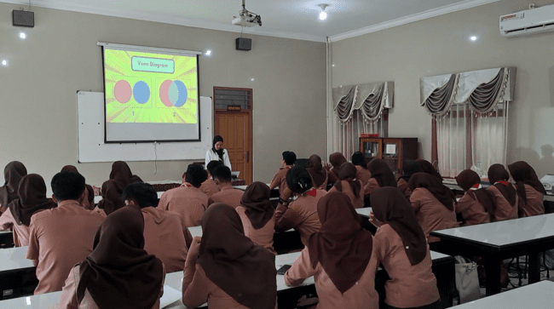
Figure 2. Subject Ask a Trigger Question

“Ketika siswa merasa bingung, saya mencoba mengidentifikasi melalui pertanyaan pemantik. Selanjutnya, saya memberikan penjelasan menggunakan metode atau pendekatan lain, misalnya dengan ilustrasi visual...saya sering menunjukkan langkah-langkah yang lebih sederhana atau contoh soal dengan tingkat kesulitan lebih rendah. Dengan ini, biasanya mereka lebih mudah memahami materi” (Wawancara, 08 Desember 2025).
Translation: “When students feel confused, I try to identify this through prompting questions. Next, I provide explanations using other methods or approaches, such as visual illustrations... I often show simpler steps or examples of problems with a lower level of difficulty. With this, they usually find it easier to understand the material” (Interview, December 8, 2025).

Based on the empirical evidence, such as dialogues between teacher and student and interview excerpts as the focus, concluded that the subject considers that in the preliminary activity, students do not yet understand or are confused in distinguishing between mutually exclusive and non-mutually exclusive events. Therefore, the subject asks a prompting question with visual illustrations using a Venn diagram. This is done so that students find it easier to understand the material.
Furthermore, in the main activity, the subject asked students to form groups to discuss the completion of the student worksheet. During the discussion process, the subject was circulated to monitor and provide guidance when students encountered difficulties. While circulating and monitoring the group work, the subject collected direct evidence of student behavior and performance. This evidence was necessary for the subject to identify the needs of each group and provide guidance when needed. Research shows that teacher movement in the classroom is one mechanism for collecting informal formative evidence that forms the basis for responding in learning (Ebby et al., 2019).
Based on the instructional strategy dimension, in the interview, the subject tried to create a comfortable and conducive learning atmosphere by arranging the seating layout for each group of students. This was done so that the discussion would run smoothly and make it easier for the subject to identify the needs of each group.
“Saya juga menyesuaikan tata letak tempat duduk untuk menciptakan suasana belajar yang lebih kondusif” (Wawancara, 08 Desember 2025).
Translation: “I also adjust the seating arrangement to create a more conducive learning atmosphere” (Interview, December 8, 2025).
Adjusting the seating arrangement is part of the instructional strategy because it is directly related to the management of learning interactions, students’ cognitive focus, and the dynamics of discussion.
After the discussion session was over, the subject asked each group about the completion status of the student worksheet and identified the parts that had not been completed. It was found that there were groups that had not finished, so the subject responded by giving them an additional 2 minutes. This practice shows that the subject had identified the students’ situational needs. However, in this section, the subject did not explore the reasons why the groups had not finished, such as conceptual difficulties, ineffective task distribution, or other factors. Therefore, the response given did not include more specific intervention measures. Identifying learning needs that only focus on task completion may result in less in-depth responses (Ebby et. al., 2019).
The actions described demonstrate the subject’s ability to respond to student behavior and performance and make operational decisions (Rofiki et al., 2025). However, the video analysis results show that the identification of student needs is still based on surface indicators such as correct or incorrect answers, speed of completion, or observation of students’ physical activities. Responding in R1 is evident, but it does not focus on deep cognitive inference; rather, it is oriented toward student performance. This is consistent with the findings by Luna & Selmer (2021), that responding is a challenging component for pre-service teachers in the early stages of professional learning.
This finding reinforces the view that responding in teacher noticing is not merely a technical action but depends on the depth of teachers’ interpretation of students’ thinking. When responses are based only on surface indicators, the resulting instructional actions tend to remain procedural, supporting the notion that noticing must reach deeper levels of interpretation to generate meaningful responses. In learning practice, this suggests the need for teacher education programs to provide structured opportunities for pre-service teachers to analyze students’ thinking beyond observable performance, for example, through video-based reflection.

Subcategory Responding 2 (R2)
The subject motivates students by providing information about the benefits of learning about compound probability in real life. These benefits include choosing strategies in games, investment decisions, weather forecasting, and finding out the probability of students entering college. The problems presented in the student worksheet are also based on real life. The subject builds students’ understanding of the benefits of compound probability material by linking it to real-world contexts.
This response marks an effort to increase student engagement. Research shows that contextual teaching and learning methods have been proven effective in increasing student engagement (Iswati et al., 2025; Rosalina et al., 2024). The subject demonstrated strong self-efficacy in their ability to actively engage students in learning. This was based on the interview results.
”Saya memberikan penjelasan menggunakan ilustrasi visual, analogi, atau konteks yang lebih dekat dengan keseharian siswa. Menurut saya, mengaitkan pembelajaran dengan permasalahan sekitar membantu mereka termotivasi belajar dan mengerjakan tugas” (Wawancara, 08 Desember 2025).
Translation: “I provide explanations using visual illustrations, analogies, or contexts that are closer to the students’ daily lives. In my opinion, relating learning to issues around them helps motivate them to learn and do their assignments” (Interview, December 8, 2025).
This indicates that the subject believes they are capable of using various contexts and strategies that can encourage student engagement.
Based on the interview on the instructional strategies dimension, the subject stated that in designing questions, he uses contexts that are close to the students’ lives so that the questions feel relevant. This shows that the subject believes in his ability to design meaningful learning that can help students relate abstract concepts to concrete situations.
After providing motivation, the subject then presented examples of compound events and explained that the first example was a disjoint event because there were no common elements between the two sets (no intersection). Meanwhile, the second example was a non-disjoint event because there were common elements between the two sets (there was an intersection). The subject also presented a formula for determining the probability of independent events and dependent events using PPT, as shown in Figure 3. Teaching materials that consist solely of concepts result in pre-service mathematics teachers having insufficient competencies (Darmawan et al., 2023).

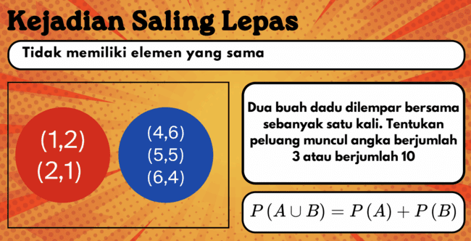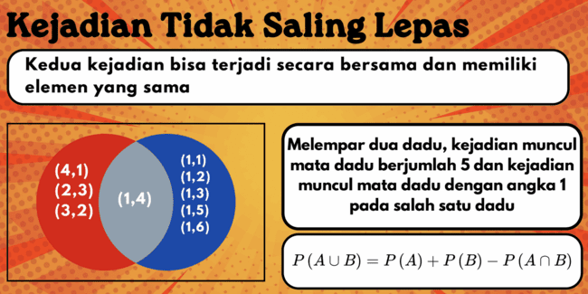
Figure 3. PPT Display of Mutually Exclusive and Non-Mutually Exclusive Events

However, the analysis found that the actions taken by the subject related to R2 were mostly explanatory moves, where the teacher demonstrated and explained, while the students only followed. Teachers should make eliciting moves that encourage students to develop new ways of thinking on their own (Ellis et al., 2019). This finding is in line with studies that teachers often use expository strategies (Sanyata et. al., 2024; Gapari, 2025).
The findings indicate that self-efficacy plays a role in shaping how teachers design strategies to engage students, particularly in connecting mathematical concepts to real-life contexts. This supports the view that affective beliefs influence not only instructional decisions but also the quality of student engagement. This implies that strengthening self-efficacy in teacher education should not be limited to confidence-building, but also linked to the development of contextual and meaningful instructional strategies.

Subcategory Responding 3 (R3)
The third subcategory of the responding aspect in teacher noticing is the subject recommending the next learning steps. R3 is evident in learning activities through the following actions. The subject structures the learning flow, starting from explanation, group discussion, presentation, conclusion, and post-test. After explaining the meaning of compound events, the subject asked the question.
“Ada yang mau ditanyakan dulu sebelum lanjut?” (Translation: “Does anyone have any questions before we continue?” )
The students replied
“Tidak”. (Translation: “No.” )
So, the subject continued the explanation of the representation of independent and dependent events using a Venn diagram, as shown in Figure 4.
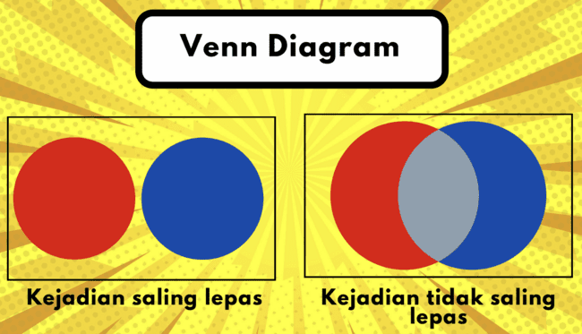
Figure 4. PPT Display of Venn Diagram

After explaining independent and dependent events, the teacher continued by instructing the students to conduct group discussions to complete the student worksheet. When the discussion time was almost over, the subject directed each group to immediately complete the student worksheet because it would be discussed in the group presentation. Then the subject closed the group discussion session and continued with group presentations as shown in Figure 5. After the discussion and presentation, the subject asked the students to conclude the probability of mutually exclusive and non-mutually exclusive events based on the results of completing the student worksheet. Then the subject continued with an ice-breaking activity in the form of guessing words through emoji pictures. Finally, the subject asked the students to take a post-test and fill out a learning reflection through Mentimeter.

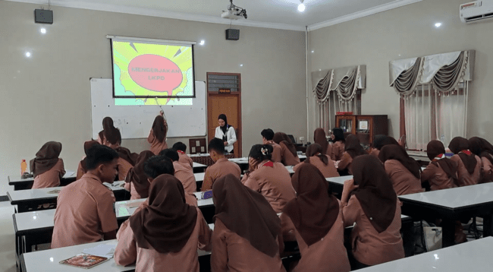
Figure 5. Presentation Activity

The subject’s responses showed confidence in his ability to manage learning systematically. When the subject asked students to reflect on their learning, it was in line with the interview in the student engagement dimension.
“Saya membantu siswa menghargai proses belajar dengan menekankan pentingnya usaha dan ketekunan, bukan hanya nilai akhir. Saat pembelajaran, saya sering mengajak siswa merefleksikan apa yang mereka pelajari dan bagaimana mereka mencapainya” (Wawancara, 08 Desember 2025).
Translation: “I help students appreciate the learning process by emphasizing the importance of effort and perseverance, not just the final score. During learning, I often invite students to reflect on what they have learned and how they achieved it” (Interview, December 8, 2025).
The subject considers student involvement and effort in the learning process to be important.
Based on the results of this analysis, the subject demonstrated the ability to recommend follow-up steps and provide specific guidance based on class progress. However, the subject’s actions were often based on the mere assumption that there were no problems (“no questions?”), which should have been based on in-depth observation of student understanding. In teacher noticing, ideally, the teacher’s response should be made after an interpretation that shows the students’ cognitive readiness (Santoso & Kurniasih, 2024). In this case, it appears that the learning flow is oriented towards completing the agenda rather than instructional adaptation based on student understanding. Research on teacher noticing emphasizes that recommendations for adaptive instructional strategies require more in-depth interpretation (König et al., 2022).
The findings in R3 indicate that the subject is able to determine subsequent learning steps. However, these decisions are still based on general classroom responses rather than a deep interpretation of students’ thinking. This suggests that responding at the level of decision-making does not necessarily reflect high-quality noticing without sufficient cognitive analysis. This implies that teacher education should support prospective teachers in making learning decisions based on diagnostic evidence of students’ understanding, rather than relying on surface-level classroom indicators.

Subcategory Responding 4 (R4)
The last subcategory of the responding aspect is proposing alternative learning strategies to achieve learning objectives. R4 appears when the subject repeatedly suggests that the group divide each problem on the student worksheet among the group members. This is done so that each member has their own responsibilities, and the student worksheet can be completed more efficiently. This is in line with the interview quote in the classroom management dimension,
“I set a clear structure for activities, such as division of roles, discussion rules, and the flow of group task completion” (Interview, December 8, 2025).
Clear division of responsibilities is an effective alternative strategy to increase participation and the quality of group discussion outcomes (Gillies, 2016; OECD 2020).
In addition, the subject also gave several instructions to solve word puzzles related to opportunities using horizontal, downward, or reverse methods from right to left. These instructions were given after the subject realized that some groups were having difficulty solving the word puzzles. During the small group discussion, the subject approached Group 4 and interpreted that the students were having difficulty operating with fractions, as shown in Figure 6. As a form of responding, the subject gave instructions to directly add the numerators because the denominators of the two fractions were the same. The teacher’s attention in learning can assist the teacher in determining the right steps to respond to student activities and thoughts (Lusiana et. al, 2024).

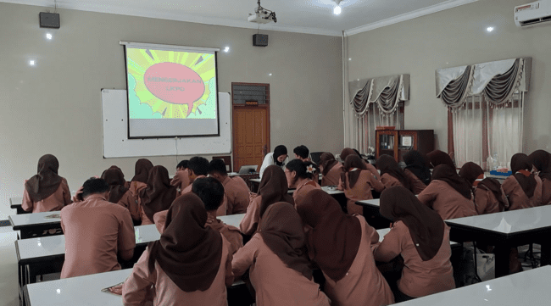
Figure 6. Subject Give Instructions to Group 4

In learning practice, subjects proposed alternative learning strategies as in R4. However, the strategies provided were still procedural in nature, causing students to mechanically follow mathematical procedures without a logical basis (Darmawan et al., 2024). In mathematics learning, it is important for teachers to maintain a balance between procedural efficiency and the development of conceptual understanding (Mulyono & Hapizah, 2018). The tendency to propose procedural strategies in R4 shows that the ability to generate alternative actions does not automatically lead to conceptually oriented instruction. This indicates that responding requires not only flexibility in strategy but also strong pedagogical content knowledge to support deeper learning.

CONCLUSION AND SUGGESTIONS
This case study research shows that the responding aspect in teacher noticing by pre-service mathematics teachers appears consistently during learning. The findings indicate that different responding aspects contribute to various dimensions of self-efficacy. However, the responses found were still at the procedural response level, so they did not reach the level of responses based on analysis of students’ thinking that could encourage conceptual understanding. This suggests that the ability to respond does not necessarily reflect deep analysis of students’ thinking.
Self-efficacy was classified as good, especially in the dimension of student engagement, but slightly lacking in the dimensions of instructional strategies and classroom management. These findings contribute to the importance of developing teacher noticing skills, particularly the responding aspect in mathematics teacher education programs, as an effort to build responsive pedagogical practices based on strong self-efficacy.
This study is limited to a single case, and therefore the findings are context-specific. The limitations of this study may open opportunities for further research to use more and varied data, as well as to focus on other aspects of teacher noticing.

ACKNOWLEDGEMENT
The author gratefully acknowledges the lecturer for valuable guidance and constructive feedback provided throughout the research process. Appreciation is also extended to the research subject, pre-service mathematics teacher who participated in this study for their willingness, cooperation, and meaningful contributions during the research process.

REFERENCES
Astuti, T. A., & Jailani, J. (2021). Kontribusi kompetensi guru matematika SMP terhadap prestasi belajar siswa. Jurnal Riset Pendidikan Matematika, 7(2), 241–253. https://doi.org/10.21831/jrpm.v7i2.16453.
Bandura, A. (1995). Exercise of personal and collective efficacy in changing societies. In A. Bandura (Ed.), Self-efficacy in changing societies (pp. 1–45). Cambridge University Press.
Bjerke, A. H., & Xenofontos, C. (2024). Teachers’ self-efficacy in teaching mathematics: tracing possible changes from teacher education to professional practice. Teachers and Teaching, 30(1), 1-15. https://doi.org/10.1080/13540602.2023.2219982.
Black, P., & Wiliam, D. (2009). Developing the theory of formative assessment. Educational Assessment, Evaluation and Accountability, 21, 5–31. https://doi.org/10.1007/s11092-008-9068-5.
Brassil, C. E., & Couch, B. A. (2019). Multiple-true-false questions reveal more thoroughly the complexity of student thinking than multiple-choice questions. International Journal of STEM Education, 6(16). https://doi.org/10.1186/s40594-019-0169-0.
Creswell, J. W., & Guetterman, T. C. (2018). Educational research: planning, conducting, and evaluating quantitative and qualitative research ( 6th Ed). Pearson.
Darmawan, P., Rofiki, I., Mutia, T., Slamet, Nugroho, C. M. R., Dewi, V. M., Pramudya, S.S., & Alaiya, S. V. (2024). Eksplorasi computational thinking calon guru matematika dalam menyelesaikan soal pola bilangan. Jurnal Pendidikan MIPA, 14(4), 1049-1059. https://doi.org/10.37630/jpm.v14i4.2049.
Darmawan, P., Yohanes, B., & Hadi, M. R. (2023). Analisis penyebab rendahnya kemampuan pemecahan masalah calon guru matematika menggunakan APKL, USG, dan diagram fishbone. Jurnal Tadris Matematika, 6(2), 199-218. https://doi.org/10.21274/jtm.2023.6.2.199-218.
Darmawan, P., & Yusuf, F. I. (2022). Teori kognitivisme dan penerapannya dalam penelitian pendidikan matematika. Insan Cendekia Nusantara.
Ebby, C. B., Remillard, J., & D’Olier, J. H. (2019). Pathways for analyzing and responding to student work for formative assessment: the role of teachers’ goals for student learning (Working Papers). Consortium for Policy Research in Education.
Ellis, A., Özgür, Z., & Reiten, L. (2019). Teacher moves for supporting student reasoning. Mathematics Education Research Journal, 31, 107-132. https://doi.org/10.1007/s13394-018-0246-6.
Gapari, M. Z. (2025). Strategi guru dalam meningkatkan kemampuan berfikir kritis siswa kelas VII melalui model pembelajaran berbasis keterampilan di MTs NW Selebung Ketangga. AS-SABIQUN, 7(2), 322-335. https://ejournal.stitpn.ac.id/index.php/assabiqun/article/view/5646.
Gillies, R. M. (2016). Cooperative learning: Review of research and practice. Australian Journal of Teacher Education (Online), 41(3), 39-54. https://doi.org/10.14221/ajte.2016v41n3.3.
Hettinger, K., Lazarides, R., & Schiefele, U. (2024). Longitudinal relations between teacher self-efficacy and student motivation through matching characteristics of perceived teaching practice. European Journal of Psychology of Education, 39(2), 1299–1325. https://doi.org/10.1007/s10212-023-00744-y.
Iswati, I., Sukarman, S., & Faqih, A. (2025). Pengaruh metode contextual teaching and learning untuk meningkatkan kompetensi pada materi realitas sosial (studi kasus: kelas X MAN 1 Jepara). AKADEMIK: Jurnal Mahasiswa Humanis, 5(1), 539-550. https://doi.org/10.37481/jmh.v5i1.1258.
Jacobs, V. R., Lamb, L. L. C., & Philipp, R. A. (2010). Professional noticing of children’s mathematical thinking. Journal for Research in Mathematics Education, 41(2), 169–202. https://doi.org/10.5951/jresematheduc.41.2.0169.
Jentsch, A., & König, J. (2022). Teacher competence and professional development. In International handbook of comparative large-scale studies in education: Perspectives, methods and findings (pp. 1-17). Cham: Springer International Publishing. https://doi.org/10.1007/978-3-030-88178-8_38.
Johar, R., Desy, D., Ramli, M., Sasalia, P., & Walker, H. O. (2023). Preservice teachers’ noticing skills in relation to student misconceptions in algebra. European Journal of Educational Research, 12(2), 865-879. https://doi.org/10.12973/eu-jer.12.2.865.
Julianawati, A. A., & Darmawan, P. (2025). Proses pemecahan masalah peluang oleh calon guru matematika berdasarkan kerangka polya. ELIPS: Jurnal Pendidikan Matematika, 6(1), 17-33. https://doi.org/10.47650/elips.v6i1.1561.
König, J., Santagata, R., Scheiner, T., Adleff, A. K., Yang, X., & Kaiser, G. (2022). Teacher noticing: a systematic literature review of conceptualizations, research designs, and findings on learning to notice. Educational research review, 36, 100453. https://doi.org/10.1016/j.edurev.2022.100453.
Kristanto, Y. D., & Melissa, M. M. (2023). Exploring preservice mathematics teachers’ noticing of students’ thinking on probability. In Proceedings of the 7th International Symposium on Mathematics Education and Innovation (ISMEI 2022) (pp. 9-13). https://doi.org/10.2991/978-94-6463-220-0_3.
Lau, W. W. F. (2022). Predicting pre-service mathematics teachers’ teaching and learning conceptions: the role of mathematical beliefs, mathematics self-efficacy, and mathematics teaching efficacy. International Journal of Science and Mathematics Education, 20(6), 1141-1160. https://doi.org/10.1007/s10763-021-10204-y.
Luna, M., & Selmer, S. (2021). Examining the responding component of teacher noticing: a case of one teacher’s pedagogical responses to students’ thinking in classroom artifacts. Journal of Teacher Education, 72(5), 579-593. https://doi.org/10.1177/00224871211015980.
Lusiana, R., Sa’dijah, C., Subanji, S., & Chandra, T. D. (2024). Elementary teachers’ noticing of students’: how to stimulate students’ critical and creative thinking. TEM Journal, 13(2), 1319-1330. https://doi.org/10.18421/TEM132-46U34T.
Mentari, V. P., & Pratama, F. W. (2024). Teacher’s self-efficacy of pre-service mathematics teacher students in micro teaching. Edunesia: Jurnal Ilmiah Pendidikan, 5(2), 893-909. https://doi.org/10.51276/edu.v5i2.905.
Mulyono, B., & Hapizah, H. (2018). Pemahaman konsep dalam pembelajaran matematika. Kalamatika: Journal of Mathematics Education, 3(2), 103-122. https://doi.org/10.22236/KALAMATIKA.vol3no2.2018pp103-122.
Monson, D., Krupa, E., Lesseig, K., & Casey, S. (2020). Developing secondary pre-service teachers’ ability to respond to student work. Journal of Mathematics Teacher Education, 23(2), 209-232. https://doi.org/10.1007/s10857-018-9420-8.
OECD. (2020). PISA 2018 results (volume V): effective policies, successful schools. OECD Publishing. https://doi.org/10.1787/ca768d40-en.
Osmanoğlu, A. (2024). An investigation on a pre-service teacher’s professional noticing skills in the process of narrative construction and discussion. Pedagogical Perspective, 3(2), 343–357. https://doi.org/10.29329/pedper.2024.75.
Pitaloka, M. D., & Darmawan, P. (2025). Fenomenologi math anxiety pada mahasiswa pendidikan matematika sebagai calon guru matematika. Proximal: Jurnal Penelitian Matematika dan Pendidikan Matematika, 8(1), 471-481. https://doi.org/10.30605/proximal.v8i1.5475.
Rindiani, R., & Sari, W. A. A. (2025). Tantangan dan strategi peningkatan kompetensi profesional guru matematika: studi kasus di SMPN 45 Pekanbaru dan Pondok Pesantren Al Mujtahadah Pekanbaru. Sindoro: Cendikia Pendidikan, 14(3), 31–40. https://garuda.kemdiktisaintek.go.id/documents/detail/5217248.
Rofiki, I., Darmawan, P., Faizah, S., Sani, M., Nugroho, C. M. R., Maulidiawati, T., & Hidayah, F. (2025). Numerasi calon guru sekolah dasar dalam menyelesaikan soal cerita: Suatu studi kasus. Kognitif: Jurnal Riset HOTS Pendidikan Matematika, 5(2), 882–898. https://doi.org/10.51574/kognitif.v5i2.2991.
Romli, A. B. S. & Darmawan, D. (2025). Pengaruh kompetensi pedagogik guru terhadap hasil belajar siswa setingkat menengah kejuruan. Journal of Management and Islamic Education, 3(2), 130–146. https://doi.org/10.61132/jmpai.v3i2.979.
Santagata, R., & Yeh, C. (2016). The role of perception, interpretation, and decision making in the development of beginning teachers’ competence. ZDM Mathematics Education, 48, 153–165. https://doi.org/10.1007/s11858-015-0737-9.
Santoso, F. G. I., & Kurniasih, R. (2024, December). Peran noticing guru dalam mengatasi hambatan epistemologi siswa pada pembelajaran matematika. In Seminar Nasional Hasil Penelitian dan Abdimas STKIP PGRI Pacitan 2024 (pp. 1-9), 3. STKIP PGRI Pacitan.
Sanyata, Y. P. D., Aulia, Y., Nisa, Z. L., Karisima, N. N. P., & Ferryka, P. Z. (2024). Penerapan strategi pembelajaran ekspositori di SDN 1 Beluk terhadap mata pelajaran matematika. Jurnal Teknologi Pendidikan dan Pembelajaran, 2(1), 151-156. https://jurnal.kopusindo.com/index.php/jtpp/article/view/239.
Taşdan, B. T., & Kabar, M. G. D. (2022). Pre-service mathematics teachers’ responding to student thinking in their teaching experiences. Journal of Pedagogical Research, 6(1), 87–109. https://doi.org/10.33902/JPR.202217555.
Tschannen-Moran, M., & Hoy, A. W. (2001). Teacher efficacy: capturing an elusive construct. Teaching and Teacher Education, 17, 783-805. https://doi.org/10.1016/S0742-051X(01)00036-1.
Ulum, M., Riyanto, Y., & Setyowati, S. (2024). Self efficacy guru sebagai kunci keberhasilan pengajaran. Jurnal Administrasi Pendidikan Islam, 6(2), 212-229. https://doi.org/10.15642/japi.2024.6.2.212-229.
Ulusoy, F., & Çakıroğlu, E. (2021). Exploring pre-service teachers’ noticing of students’ understanding through micro-case videos. Journal of Mathematics Teacher Education, 24, 253-282. https://doi.org/10.1007/s10857-020-09457-1.
van Es, E. A., & Sherin, M. G. (2021). Expanding on prior conceptualizations of teacher noticing. ZDM Mathematics Education, 53, 17-27. https://doi.org/10.1007/s11858-020-01211-4.
Weyers, J., König, J., Scheiner, T., Santagata, R., & Kaiser, G. (2024). Teacher noticing in mathematics education: a review of recent developments. Videobasierte Kompetenzmessung in der universitären Lehrkräfteausbildung, 103-133. https://doi.org/10.1007/978-3-658-46018-1_11.
Rosalina, Widyaswarani, E., Saputra, F. A., Nurcholis, R. A., & Lutfiana, A. F. (2024). Implementasi contextual teaching learning dalam pembelajaran untuk meningkatkan keaktifan siswa. Paradigma:Jurnal Filsafat, Sains, Teknologi, dan Sosial Budaya, 30(5), 58-65. https://ejurnal.uibu.ac.id/index.php/paradigma/article/view/855.
Zee, M., & Koomen, H. M. Y. (2016). Teacher self-efficacy and its effects on classroom processes, student academic adjustment, and teacher well-being: a synthesis of 40 years of research. Review of Educational Research, 86(4), 981–1015. https://doi.org/10.3102/0034654315626801.

