Available online to www.journal.unipdu.ac.id

S2-Accredited – SK No. 34/E/KPT/2018
Journal Page is available to www.journal.unipdu.ac.id:8080/index.php/register

Investigate the factors that influence the acceptance of fintech lending services: A perspectives from Indonesian borrowers

Yekti Wirani ª, Randi ^{b}, Muh Syaiful Romadhon ^{c}
^{a,b,c} Department of Information Systems, Nurul Fikri College of Technology, Depok, West Java, Indonesia
email: ª yekti@nurulfikri.ac.id, ^{b} randim250498@gmail.com, ^{c} syaiful@nurulfikri.ac.id
A R T I C L E I N F O |  | A B S T R A C T
Article history:  Received 24 January 2020 Revised 30 April 2020 Accepted 2 December 2020 Available online xxx |  | Financial Technology (FinTech) in Indonesia is the innovative solutions for financial services in Indonesia. FinTech has convenience and benefits for Indonesians who need loans, fund management, and other financial transaction activities. FinTech's rapid development in Indonesia is FinTech Lending because it offers cheaper interest rates and more convenient access than conventional financial institutions. The growth of FinTech Lending is expected to support financial inclusion planned by the Indonesian government. The development of FinTech Lending in Indonesia faces challenges. In 2020, 126 FinTech Lending are operating illegally by exploiting communities experiencing economic difficulties. This study designs to identify the factors that impact the acceptance of lending-based FinTech services in Indonesia based on problems and opportunities. Factors related to problems are Trust and Security in Online Lending Platform, while factors related to opportunities are Familiarity, Interest Rate, and Personal Innovativeness. This study processed 85 respondents and processed the data using Partial Least Square-Structural Equation Modeling (PLS-SEM). The results are Familiarity and Personal Innovativeness affects the acceptance of FinTech Lending services in Indonesia. This research also produces recommendations for the development of FinTech Lending in Indonesia. The resulting recommendations can be used to develop FinTech Lending so that it can support financial inclusion in Indonesia.
Keywords:
FinTech Lending
Familiarity
Personal Innovativeness
Online Lending
Finansial Inclusion
IEEE style in citing this article: [citation Heading]
F. Fulan and F. Fulana, "Article Title," Register: Jurnal Ilmiah Teknologi Sistem Informasi, vol. 7, no. 1, pp. 1-10, 2021. [Fill citation heading]
2021 Register: Jurnal Ilmiah Teknologi Sistem Informasi (Scientific Journal of Information System Technology) with CC BY NC SA license.
- Introduction [Heading of Section]
The growth of technology use in Indonesia is so fast, as evidenced by the increasing number of mobile and internet device users [1]. These technological advances affect all areas and aspects of life [2]. This influence has had an enormous impact, especially in the social and economic fields [3]. There have been many new technology-based innovations in the economic area, one of which is the emergences Financial Technology, known as FinTech [4]. FinTech is a digital platform that combines financial services with technology [5]. The presence of FinTech provides innovative solutions to financial services and disrupts financial institutions [6]. The FinTech platform's presence aims to provide accessible services for people who need funds, manage funds, make purchases, and other transaction activities related to finance [7]. FinTech has various advantages and conveniences and is cheaper than conventional financial institutions [8][9]. Financial transactions using the FinTech platform are faster, easier, and more efficient [7].
FinTech companies are divided into five service categories: financial planning and budgeting, transfers and payments, borrowing, savings and investments, and insurance [5]. FinTech services' diversity provides comprehensive convenience in various community activities in Indonesia [10]. Currently, FinTech companies in Indonesia consist of several sectors, namely payments (42.2%), lending (17.8%), aggregators (12.6%), and crowdfunding (8.2%), with growth reaching 172.86% [11]. One of the sectors needed by people in Indonesia is FinTech Lending. FinTech Lending services help people who need funds for consumptive or productive needs through loans provided online [12]. In addition to providing innovative service variations, FinTech Lending offers lower interest rates and varied prepaid returns compared to non-FinTech intermediaries [13].
As of June 11, 2020, 160 FinTech Lending companies have been registered and have a license from the Financial Services Authority [14]. The rapid development of FinTech Lending services is expected to help realize inclusive finance for the Indonesian people and drive the national economy [15]. According to Bank Indonesia [16], financial inclusion provides in-depth financial services for the bottom of the pyramid community. People with the bottom of pyramid type are people with shallow and fluctuating incomes, live in inaccessible areas, people with disabilities, laborers who do not have legal personality documents, and marginalized society. Most of the people with this type are unbanked and have a high proportion in developed countries.
FinTech's journey to support financial inclusion also encountered obstacles, namely complaints from the public regarding FinTech Lending services. Based on a press release conducted by the Financial Services Authority through the Investment Alert Task Force, 126 FinTech-based illegal borrowings do not have a license [17]. FinTech Lending which operates illegally and deliberately takes advantage of people who are in financial difficulty during the Covid-19 pandemic and cause losses. Also, there are reports of privacy violations committed by FinTech based lending, which send messages to borrower contacts to humiliate the borrower and hasten loan repayments [18]. The existence of illegal FinTech Lending, which is still operating, gives a bad impression on the FinTech industry to reduce public confidence in using legal FinTech Lending services. Research conducted by [11] shows that the side of trust in FinTech Lending still indicates a negative perception.
This study designs to analyze the factors that effect the acceptance of FinTech Lending services. The factors that will be studied come from the opportunities and problems found in FinTech Lending in Indonesia. Factors related to FinTech opportunities are the wide variety of features and services offered so that users can try to explore and innovate with the solutions offered. These opportunities are also related to users who are increasingly familiar with FinTech features and services, the more they want to use the FinTech platform. Also, FinTech Lending is believed to offer a lower interest rate than non-FinTech intermediaries; of course, this will encourage users to be interested in using its services. Apart from these opportunities, FinTech is also faced with low public trust in FinTech service providers and the security promised by providers in the form of legal procedures and rules. These factors are expected to be a guideline that can provide knowledge and understanding to the public regarding FinTech Lending. Also, this study's outcome can be used as recommendations for Fintech Lending service providers in improving the quality of their services in Indonesia. Improving the quality of services at FinTech lending in Indonesia can support the Indonesian government's program, namely realizing financial inclusion for the Indonesian people.
- State of the Art
The FinTech business model has developed significantly over the past few years to provide financial transaction services to complement the retail banking industry. The FinTech business is increasingly innovative because it is supported by technological developments such as online banking, online payment, algorithmic trading, and cryptocurrencies [19]. FinTech is a mix of financial services and products with a technology platform by leveraging innovative business models [20]. In general, FinTech can be classified into Payment Technology (PayTech), Banking Technology (BankTech), Wealth Technology (WealthTech), Insurance Technology (Insurtech), and Regulation Technology (RegTech) [21]. Meanwhile, in Indonesia, there are four categories of FinTech, namely (1) deposit, lending, capital raising; (2) payment, clearing, settlement; (3) investment & risk management; dan (4) market provisioning [20]. This research focuses on FinTech with the categories of deposit, lending, and capital rising.
The institution that serves as the payment system authority will encourage, assist FinTech innovation, and ensure the alignment of FinTech with policies in Indonesia is Bank Indonesia [20]. Also, to support the development and innovation of FinTech, Bank Indonesia facilitates space for FinTech organizers to test services, products, technology, and business models through the Regulatory Sandbox [22]. Meanwhile, the Financial Services Authority (OJK) is an institution that oversees the activities of FinTech, which provides financing services [23]. Based on data compiled from the OJK [24] in August 2020, 158 FinTech Lending registered with the OJK. Unfortunately, only 33 FinTech had business licenses, while the rest had not.
The following are the previous studies about FinTech that form the basis for the model developed in this study:
- Research conducted by [25] uses the UTAUT2 framework with Go-Pay service users' perspective in Indonesia. This research analyzes the variables of Performance Expectancy, Effort Expectancy, Social Influence, Facilitating Condition, Price Saving Orientation, Hedonic Motivation, Habit, Trust, and Continuance Intention. This study collected data from 507 Indonesian respondents. This study concludes that the factors that influence Go-Pay adoption are Habit, Social Influence, Trust, Hedonic Motivation, Price Saving Orientation, and Performance Expectancy. The recommendation produced by this research to Go-Pay management is the need to set a priority scale for business strategy development on Go-Pay. The recommendation produced by this study to Go-Pay management is the need to set a priority scale for business strategy development on Go-Pay. Besides that, Go-Pay must know the preferences of its users.
- Research conducted by [26] analyzed the use of the online payment, namely CashU.com, with Arab citizens' perspective. This research involved 350 online shoppers from Kuwait who have purchased products or services via the internet. This study analyzes the influence of Perceived Enjoyment, Customer Trust, and Perceived Risk on the intention to adopt CashU.com. This research also examines the influence of Personal Innovativeness on Perceived Enjoyment and Customer Trust, the influence of Propensity Trust on Customer Trust, the effect of Familiarity on Customer Trust, the influence of Presence of Third-Party Seals on Customer Trust and Perceived Risk, and the influence of Perceived Enjoyment and Perceived Risk to Customer Trust. This research shows that Customer Trust and Perceived Enjoyment are proven to influence online payment adoption.
- Besides, there is research conducted by [27] with users' perspective of FinTech Lending services in Indonesia. This study aims to find the factors that influence the willingness of small and medium enterprises (SMEs) to cover peer-to-peer (P2P) lending as an alternative to financing. This study collected qualitative data obtained from ten respondents in Bandung using interviews. This study's results are the Loan Process, Interest Rates, Loan Cost, Loan Amount, and Loan Flexibility, which affect the use of FinTech Lending Also, this study found an Alternative Payment Scheme for sharia-based lending. This research also provides recommendations for P2P lending operators that respondents will be interested in using their services if interest rates are low, Sharia-based loans, long payback periods, have a profit-sharing system, and get a rejection from banks.
- Research conducted by [28] using an investor's perspective on P2P lending-based FinTech services in Indonesia. This study involved participation from 214 SMEs in Indonesia using survey techniques. The results of the study were analyzed using PLS-SEM. This study's results are the factors that influence the desire to invest in lending platforms are Familiarity, information quality from third-party borrowers, investor risk acceptance, fund-raising projects, and trust on P2P lending platforms. The conclusion is that investors will use the service if the risk owned by the borrower is small. Also, investors will be attracted if the loan project type is fund-raising.
- Research conducted by [29] analyzed the Continuance Intention of famous mobile payments in China. The result of this research is that the trust process from online to mobile payments positively affects the continuation of Continuance Intention on mobile payments through Satisfaction. In this research, Satisfaction is an essential factor influencing continuance intention. The results of the research confirm that Perceived Similarity, Trust in Online Payment, and Perceived Entitativity among online and mobile payment can affect Trust in Online Payment. This research provides suggestions for FinTech service providers to support the service transition process online to mobile payment.
- The research conducted by [30] analyzed income from FinTech based on borrowing using the Extended TAM framework in Indonesia. This study involved 1000 respondents who had used P2P lending services. The results of this study were analyzed using PLS-SEM. This study's results are Perceived Benefits, Trust, Usefulness, and Ease of Use affect Behavior Intention to Use in lending-based FinTech in Indonesia. This research also proves that risk and creativity have an impact on P2P lending adoption. This research also provides recommendations to determine the right media to advertise. Besides, it is essential for management to continue to innovate to improve ease of use, usefulness, and trust in its services.
Based on previous studies, this study will evaluate the influence of several factors such as Trust in Online Lending Platform, Security, Familiarity, Interest Rate, and Personal Innovativeness on the adoption of FinTech Lending in Indonesia. The factors that will be evaluated come from the opportunities and problems found in FinTech Lending in Indonesia. This study will use the perspective of borrowers on FinTech Lending services. This study collected survey data from individual users of FinTech services in Indonesia. Also, this research produces recommendations for improving FinTech Lending services in Indonesia based on borrowers’ perspective.
- Method
In this study, a series of stages were carried out to carry out the research. The series of stages starts from problem identification to forming recommendations for FinTech Lending. The stages of the research are shown in Figure 1. Based on Figure 1, this research subsists of seven stages, namely: problem recognition, literature review, model formulation, questionnaire arrangement, data compilation, data processing & analysis, and preparation of recommendations.
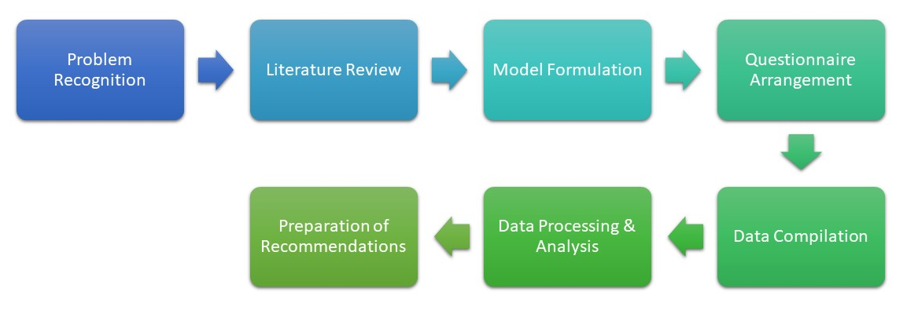
Figure 1. Research stages of FinTech Lending Intention to Use
  - Problem Recognition & Literature Review
Problem recognition is the first stage in this study. Activities carried out at this stage include interviews with two FinTech users based on Indonesia's lending, conducting data searches, and the latest information on FinTech Lending in Indonesia. The recognition of problems in this study includes the government's hope for increasing financial inclusion for people in Indonesia. However, this hope is still constrained by FinTech Lending which operates illegally and harms people who need loan funds. The presence of FinTech Lending that operates illegally can reduce the Indonesian people's confidence in legal FinTech. The next stage is a literature review that discusses theories that support research, such as FinTech and previous research related to acceptance of FinTech.
  - Model Formulation
After analyzing theory and previous research, the next step is to develop a model. The model developed in this study uses proven previous research. The model containing variables will be tested to see the effect on Intention to Use (IU) of loan-based FinTech. These variables are Interest Rate (IR), Personal Innovativeness (PI), Security (SC), Trust in Online Lending Platform (TL), and Familiarity (FM). The research model developed in this study is presented in Figure 2. There are 5 hypotheses developed in this study. The following are five hypotheses designed in this study:
- Interest rate is defined as the interest rate that must be paid by borrowers related to the risks managed by the bank by money lending [27]. Furthermore, the interest rate can also be defined as the interest rate charged to borrowers, which is used to measure the level of risk charged by lenders to borrowers [31]. This study would analyze that the interest rates provided by Fintech are more aggressive than banks. The low-interest-rate allows easy repayment of loan installments and funds because the total amount of the loan is less than offers from other conventional financial institutions. Therefore, the hypothesis offered is:
H1: Interest Rate (IR) affects the Intention to Use (IU) to use FinTech.

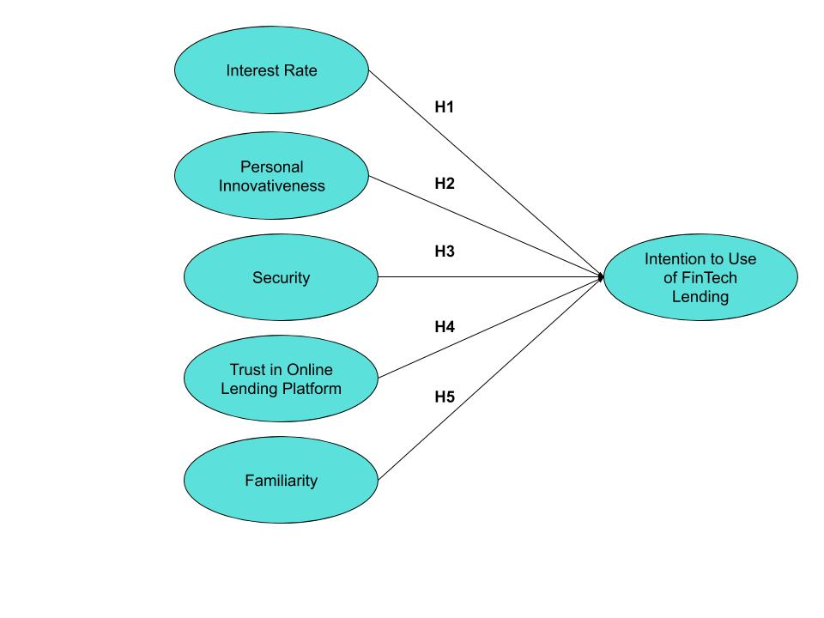
Figure 2. Conceptual Model of Fintech Lending Intention to Use Among Indonesian

- Personal Innovativeness is defined as a different reaction for everyone when adopting an innovation [26]. This reaction is a personal trait that will be found to vary from person to person. In this study, Personal Innovativeness is reflected in the form of willingness and enjoyment when using a FinTech Lending platform. Personal Innovativeness is also related to the desire to be the first to explore Fintech in their environment. Curiosity about FinTech Lending is the primary basis for the development of Personal Innovativeness. Therefore, the hypothesis designed in this study is:
H2: Personal Innovativeness (PI) influences the Intention to Use (IU) to use FinTech.
- Security is the main thing that the FinTech platform must-have. Security in this context can be understood as the security of the platform technology structure and procedures [28]. This research will evaluate that FinTech Lending has protection technology following the regulations. The security factor will also increase if the prospective borrower knows the borrowing procedure. The availability of clear loan contracts and following government legal regulations is also a factor that will increase the platform's security. Therefore, the hypothesis is:
H3: Security (SE) affects the Intention to Use (IU) to use FinTech.Trust in Online Lending Platform
- Trust is considered a factor that affects the use of mobile-based FinTech platforms [25]. Trust also has a significant influence on consumer's attitudes [30]. In this study, the Trusts evaluated are from the perspective of the provider of the Fintech Lending platform. Users believe that high trust in Fintech Lending platform providers can affect users' desire to use the service. In this study, Trust in Online Lending Platform is defined as a condition when FinTech service providers keep their promises. Besides, Trust in Online Lending Platform deals with providers of Fintech Lending platforms who are considered competent and have provided effective financial services. Therefore the hypothesis offered is:
H4: Trust (TL) affects Intention to Use (IU) to use FinTech.
- Familiarity can be represented by familiarity with complexity and uncertainty related to the platform provider's interface, procedures, and reputation [26]. Users believe that the more familiar with the platform, the more users will want to use it. In this study, Familiarity is represented by user habits towards procedures on the FinTech platform. Also, the familiarity of the platform's interface affects the user's willingness to continue using the service. Users also desire to use FinTech services if the service provider is proven to have a good reputation among the Indonesian people. Therefore, the hypothesis designed in this study is:
H5: Familiarity (FM) affects Intention to Use (IU) to use FinTech.
  - Questionnaire Arrangement
After the hypothesis is developed, the next step is making a questionnaire. Questionnaire in this study is in Table 1. After the questionnaire was created, the next step was to conduct a readability test for 5 potential respondents who had used loan-based FinTech services. This readability test is carried out to determine potential respondents' understanding and find equivalent words that cause misinterpretation [32]. In this study, 24 indicators are used to evaluate the IR, PI, SC, TL, FM, and IU variables as in Table 1. These indicators are obtained from previous studies which also use variables that have similarities. These indicators will be tested using reliability and validity testing. The questionnaire to be distributed consists of two parts, namely the first part used to obtain information about the respondents' demographics. The second part is a statement to receive the variables in this study. This research adopts a Likert scale with a area of 1 to 4. The value range one is used to strongly disagree, value two states disagree, value three states agree, and value four states strongly agree.
Table 1. Research Questionnaire
Variable | Indicator | Items
Interest Rate (IR) | IR1 | The interest rates proposed by FinTech are more competitive than banks
 | IR2 | Low interest rates allow easy installment payments
 | IR3 | Low interest rates allow easy repayment of loan funds
 | IR4 | Low interest rates reduce the possibility of default
Personal Innovativeness (PI) | PI1 | I want to be the first to use FinTech
 | PI2 | I would like to know about FinTech, like its features, benefits and how to use it
 | PI3 | I am interested in trying FinTech
 | PI4 | I have a great time trying out new technologies like FinTech
Security (SC) | SC1 | FinTech has regulatory protection technology
 | SC2 | FinTech has clear loan procedures
 | SC3 | FinTech has loan procedures that comply with legal regulations
 | SC4 | I feel safe making a loan at FinTech
Trust in Online Lending Platform (TL) | TL1 | I trust Fintech service providers to keep their promises
 | TL2 | I trust FinTech service providers to be competent and effective at providing financial services
 | TL3 | I feel that without being regularly monitored, the loan amount is still safe
 | TL4 | I trust the benefits provided by FinTech
Familiarity (FM) | FM1 | I am familiar with the procedures for loans at FinTech
 | FM2 | I feel used to the FinTech display (interface)
 | FM3 | FinTech service providers have a clear reputation
 | FM4 | I am used to making loan transactions with FinTech
Intention to Use (IU) | IU1 | I want to use FinTech as a loan platform
 | IU2 | I want to use FinTech continuously
 | IU3 | I would recommend using FinTech
 | IU4 | If needed, I will use FinTech instead of bank applications
  - Data Compilation, Processing, and Analysis
The later stage is that the questionnaire is disseminated to FinTech services users based on lending in Indonesia. Respondents involved in this study amounted to 85 people. After the questionnaire results are obtained, the next stage is data processing using the Partial Least Square (PLS) technique. This research uses SmartPLS v3.2.6 software. After that the data were analyzed to get the test results of reliability, validity, R2 value and path coefficients.
  - Preparation of Recommendations
After the data is analyzed, the next step is to evaluate the accepted and rejected hypotheses. The rejected hypothesis will be used as a basis for providing recommendations for improving lending-based FinTech services in Indonesia. Meanwhile, the accepted hypothesis can be used for recommendations to maintain the FinTech services that have been built. Two randomly selected respondents will validate the recommendations that have been designed. The two chosen respondents were female and male, with an age range over 30 years old because they were financially mature. The recommendation validation process is executed through interviews with the help of the Whatsapp platform.
- Results and Discussion
This field will discuss the results of data processing and analysis which are divided into several sections, namely (1) Respondents Demographics, (2) The Calculation of Measurement Model, (3) The Calculation of Structural Model, (4) Hypothesis Testing, (5) Discussion.
  - Respondents Demographics
This study involved 85 respondents with a period from March to July 2020. Respondents were asked to fill out a questionnaire placed on Google Form and distributed online through the Whatssap Group. Respondents involved came from Jakarta, Bogor, Depok, Tangerang, and Bekasi, West Java (apart from Bogor, Depok, Tangerang, and Bekasi), Central Java, and Yogyakarta. Most of the respondents involved in this study were in the age range of 20 to 25 years, while most respondents were female. The majority of respondents' education level is Bachelor. Demographic respondents are shown in Table 2.
Table 2. Respondents Demographic
Variable | Measure | Sample | Percentage (%)
Domicile | Jakarta, Bogor, Depok, Tangerang, and Bekasi | 70 | 83
 | West Java | 7 | 8
 | Central Java | 7 | 8
 | Yogyakarta | 1 | 1
Age | 20-25 years old | 73 | 86
 | 26-40 years old | 9 | 11
 | 31 until 35 years old | 2 | 2
 | 36 until 40 years old | 0 | 0
 | 41 until 45 years old | 1 | 1
Gender | Female | 48 | 44
 | Male | 37 | 56
Level of Education | Diploma | 11 | 12
 | Bachelor | 69 | 82
 | Master | 5 | 6
  - The Calculation of Measurement Model
The model's calculation can be done by testing the inner and outer models derived from the PLS algorithm. The outer model can be investigated by observing Composite Reliability (CR), Convergent Validity, and Discriminant Validity. According to [33] convergent validity can be quantified from the Average Variance Extracted (AVE) value, which is the average of the reliability of a construct and the loading factor. The research model is considered to pass the convergent validity evaluation if the AVE square root value is more than 0.50 and the loading factor value is more than 0.70. If there are indicators that do not meet the value limit, they must be eliminated. In this study, the convergent validity test results were 24 indicators had a loading factor value greater than 0.70 and 6 constructs had an AVE root value greater than 0.50, so no indicators were eliminated at this testing stage. The AVE root values ​​and loading factors are presented in Table 3.
Discriminant validity can be measured using the value of the inter-construct correlations, which indicates that each indicator has a higher correlation value for its theoretical construct than for other constructs [34]. Based on the results of the discriminant validity results, all indicators have a higher correlation value for their theoretical constructs than other constructs. The results of this test state that the indicators are appropriate and have specificities with their theoretical constructs. Next is the test on construct reliability, which can be done by observing the CR and Cronbach Alpha (CA) values. Based on [35], the research model is considered to pass the construct reliability evaluation if the value is greater than 0.70. This test's results stated that the research model passed the construct reliability test because the CR and CA values ​​were greater than 0.70. The values ​​of CA and CR are presented in Table 3.
Table 3. The Results of Outer Model Evaluation
Construct | Indicator | Loading Factor | √AVE | CA | CR
IR | IR1 | 0.728 | 0.614 | 0.782 | 0.883
 | IR2 | 0.819
 | IR3 | 0.869
 | IR4 | 0.706
PI | PI1 | 0.858 | 0.741 | 0.878 | 0.901
 | PI2 | 0.792
 | PI3 | 0.869
 | PI4 | 0.918
SC | SC1 | 0.804 | 0.722 | 0.865 | 0.899
 | SC2 | 0.912
 | SC3 | 0.873
 | SC4 | 0.805
TL | TL1 | 0.939 | 0.838 | 0.926 | 0.938
 | TL2 | 0.940
 | TL3 | 0/927
 | TL4 | 0.853
FM | FM1 | 0.931 | 0.760 | 0.894 | 0.916
 | FM2 | 0.864
 | FM3 | 0.836
 | FM4 | 0.852
IU | IU1 | 0.912 | 0.741 | 0.878 | 0.904
 | IU2 | 0.803
 | IU3 | 0.899
 | IU4 | 0.823
  - The calculation of Structural Model
After the research model goes through measurement model testing, the model will go through structural model testing. In structural model testing, an inner model evaluation will be carried out with the PLS algorithm's help. Structural model testing is also called the second stage of testing which will test the study [36]. Testing the structural model can use the R² value and the path coefficient. The value of R² shows how much the research model explains the construct for intention to use on FinTech lending in Indonesia. The range of R² values ​​is from 0 to 1 and the value 1 shows the highest level of accuracy of a research model [33]. The R² value of this study is 0.789, which means that the variability of the IU value in FinTech lending in Indonesia can be explained from the FM and PI constructs of 78.9%. Meanwhile, the remaining 21.1% is clarified by other constructs not investigated in this study. The R² value of this study is shown in Figure 3.
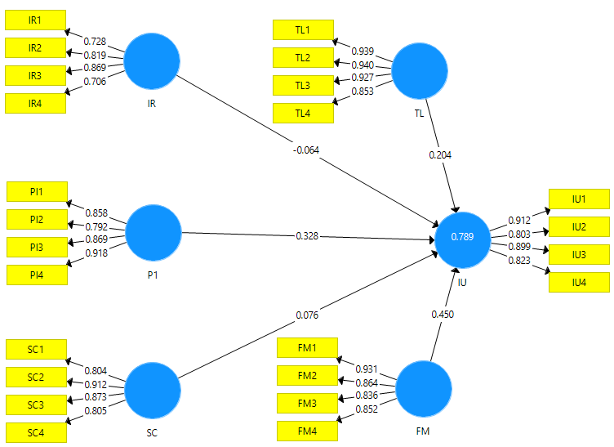
Figure 3. The Measurement Result of Research Model
  - Hypothesis Testing
Hypothesis testing is done by first determining the type of examination. This study adopts a two-tailed type of examination because the direction of the relationship from the hypothesis developed in this study is unexplained and will only be tested in this study. The level of significance used in this study was 0.05. The SmartPLS software regulates this level of significance in the bootstrap calculation section. If the selected test type is two-tailed and the significance level chosen is 0.05, then the t-value should be greater than 1.64. The results of hypothesis testing are presented in Table 4. Based on the results of hypothesis testing, it can be compeleted that FA and PI are demonstrated to affect IU.
Table 4. The Results of Hypothesis Testing
Hypothesis | Path Coefficient | t-Value | Result
FA IU | 0.01 | 3.233 | Accepted
IR IU | 0.246 | 1.161 | Rejected
PI IU | 0.016 | 2.417 | Accepted
SC IU | 0.393 | 0.856 | Rejected
TL IU | 0.110 | 1.602 | Rejected
  - Discussion
The results of this study announce that Familiarity is proven to influence Intention to Use on users of FinTech lending services in Indonesia. These results are consistent with research managed by [26] on Kuwait's online payment system. This study found that FinTech users based on lending in Indonesia will use FinTech services if they are familiar with the procedures and procedures for borrowing or if users are accustomed to borrowing on the FinTech platform. Also, users realize that when they are familiar with the FinTech platform interface, they tend to use the loan-based FinTech service. The role of loan service provider vendors with a clear and well-known reputation also affects users' willingness to use the Fintech service. FinTech lending service providers can begin to intensively introduce their services to digital media to boost the adoption of their services among Indonesians. This study proves that Personal Innovativeness is proven to effect Intention to Use on users of FinTech Lending services in Indonesia. These results are persistent with research conducted by [26]. Users want to adopt FinTech Lending services because of their desire and interest in being the first to use the service, besides that users also want to know about the features, benefits, and ways of using the FinTech platform. Users who feel pleasure when trying to use the technology offered by FinTech tend to want to use FinTech Lending services. The younger generation is a generation that tends to be curious, so Fintech Lending service providers need to provide information about their services and ensure their users get an experience according to their expectations.
This study proves that the Interest Rate, Security, and Trust in Online Lending Platform do not influence the Intention to Use in lending-based FinTech services in Indonesia. This result is not equivalent with research managed by [27][28][29][25]. This result can be explained because the interest rates offered by FinTech Lending in Indonesia are still less competitive than those offered by banks. The interest rates offered by FinTech Lending always tend to be high, so users will have difficulty paying installments and returning loan funds. High-interest rates can result in the possibility of default from service users. The security that is owned by FinTech Lending is also not considered appropriate by users. Users think that FinTech protection technology is not following the rules, the loan process is still unclear, and is not pursuing legal regulations. Security incompatibilities cause users not to feel secure when making loan transactions. Users also do not think of any trust in the FinTech Lending service provider because users feel that the service provider has not fully fulfilled its promises. Also, users think that service providers are not yet competent and effective in providing financial services. Users believe that the loan amount submitted through the FinTech Lending service must be monitored regularly to ensure there are no recording errors on the platform. Users have concerns about the platform's mistakes that can cause the loan nominal to be different from the payment recapitulation. Based on this, FinTech Lending service providers must ensure that their business has been registered and has a business license listed on the OJK website so that users can be sure that FinTech has complied with the government's rules and regulations. FinTech Lending is expected to demonstrate that FinTech must be operating in the sandbox's light-touch regulatory surrounding for one year before listing for a license. FinTech Lending service providers can also re-evaluate the number of interest rates offered by users so that they remain competitive and can compete with the banking industry and facilitate payments for users, especially when repaying installments.
- Conclusions
Correct understanding of FinTech Lending service users' needs will help service providers continue developing their platforms. Service providers must understand the problems and opportunities of FinTech Lending services from the perspective of the Indonesian people. This study proves that the factors proven to influence FinTech Lending services in Indonesia are Familiarity and Personal Innovativeness. The two factors have a path coefficient and t-value, respectively, which are Familiarity of 0.01 and 3.233; Personal Innovativeness of 0.016 and 2.417. These two factors are considered as opportunities from the FinTech Lending service. This research shows that the more information such as service descriptions, procedures, and lending procedures provided by FinTech service providers, the greater the user's desire to use FinTech Lending services. Besides, users accustomed to using services and familiar with the FinTech Lending platform's interface display will use the FinTech service. Users who desire to innovate are also likely to use FinTech Lending services, especially if these users are highly curious about the features, benefits, and ways of using the platform, and if users feel enjoyment when trying out a loan-based FinTech platform.
This research also produces findings that are useful as recommendations for FinTech Lending service providers in Indonesia. This finding is that FinTech Lending service providers can begin to introduce their services intensively on digital media. Besides that, it is crucial for service providers to ensure that their business has been registered and has a business license listed on the OJK website. FinTech Lending service providers in Indonesia also need to evaluate interest rates periodically to ensure that the offered interest rates are competitive and facilitate the repayment of installments for users.
This research still has shortcomings, such as the geographic location used does not fully cover all parts of Indonesia. Also, this study's drawback is that the number of samples is still limited with a specific age range of respondents, namely the younger generation with an age range of 20-25 years. Recommendations for further research involve business owners and businesses as respondents because they are accustomed to using loan services from the financial industry. Also, further research can design models with more and more various variables. It can relate to other models such as Technology-Organization-Environment (TOE) if it involves respondents from business owners.

6. References
[1] APJII, “Penetrasi & profil perilaku pengguna Internet Indonesia 2018,” Jakarta, 2018.
[2] M. Moslehpour, V. K. Pham, W. K. Wong, and I. Bilgiçli, “e-purchase intention of Taiwanese consumers: Sustainable mediation of perceived usefulness and perceived ease of use,” Sustainability, vol. 10, no. 1, 2018.
[3] Darmansyah, B. A. Fianto, A. Hendratmi, and P. F. Aziz, “Factors determining behavioral intentions to use Islamic financial technology: Three competing models,” Journal of Islamic Marketing, Edition August 2019, 2020.
[4] Y. Ma and D. Liu, “Introduction to the special issue on Crowdfunding and FinTech,” Finance. Innovation, vol. 3, no. 1, pp. 3–6, 2017.
[5] Ernst & Young, “Global FinTech Adoption Index 2019, https://fintechauscensus.ey.com/2019/Documents/ey-global-fintech-adoption-index-2019.pdf,” pp. 1–44, 2019.
[6] K. L. Tang, C. K. Ooi, and J. B. Chong, “Perceived Risk Factors Affect Intention To Use FinTech,” Journal of Accounting and Finance in Emerging Economies, vol. 6, no. 2, pp. 453–463, 2020.
[7] G. Kou, “Introduction to the special issue on FinTech,” Financial Innovation, vol. 5, no. 1, pp. 4–6, 2019.
[8] E. Abad-Segura, M. D. González-Zamar, E. López-Meneses, and E. Vázquez-Cano, “Financial Technology: Review of trends, approaches and management,” Mathematics, vol. 8, no. 6, pp. 1–36, 2020.
[9] A. Teja, “Indonesian Fintech Business: New Innovations or Foster and Collaborate in Business Ecosystems?,” The Asian Journal Technology Managagement, vol. 10, no. 1, pp. 10–18, 2017.
[10] C. Nuryakin, L. Aisha, and N. W. G. Massie, “Financial Technology in Indonesia: A Fragmented Instrument for Financial Inclusion?,” LPEM-FEB UI Working Papper 036, no. May, pp. 1–9, 2019.
[11] J. Tandiono, B. W. Djojo, S. Candra, and P. Heriyati, “Finding Customer Perception of Peer-to-Peer ( P2P ) Lending Financial Technology in Pohon Dana,” vol. 11, no. March, pp. 51–58, 2020.
[12] A. Tisnadisastra and A. S. Tadjoedin, “Fintech Indonesia 2020,” Fintech 2020, vol. 1, no. 1, pp. 69–75, 2019.
[13] S. Mittal, D. Joshi, and S. L. Lin, “Digital Banking New Avatar – Banks Watch Out for Banks,” 2016.
[14] Otoritas Jasa Keuangan, “Penyelenggara Fintech Terdaftar dan Berizin di OJK per 11 Juni 2020,” 2020. .
[15] L. T. Laut, F. Ekonomi, U. Tidar, D. M. Hutajulu, F. Ekonomi, and U. Tidar, “Kontribusi Financial Technology Dalam Meningkatkan,” Proseding Seminar Nasional dan Call for Papers Fakultas Ekonomi Universitas Tidar, pp. 326–336, 2019.
[16] Bank Indonesia, “Program Keuangan Inklusif Bank Indonesia,” 2013. [Online]. Available: https://www.bi.go.id/id/ssk/Peran-BI-SSK/keuanganinklusif/program/Contents/default.aspx.
[17] Otoritas Jasa Keuangan, “Siaran Pers Satgas Waspada Investasi Tutup 126 Fintech Lending Ilegal Dan 32 Investasi Tanpa Izin,” 2020. [Online]. Available: https://www.ojk.go.id/id/berita-dan-kegiatan/siaran-pers/Pages/Siaran-Pers-Satgas-Waspada-Investasi-Tutup-126-Fintech-Lending-Ilegal-dan-32-Investasi-Tanpa-Izin-.aspx. [Accessed: 29-Sep-2020].
[18] Oxford Business Groups, “How Indonesian fintech companies are boosting financial inclusion,” 2020. [Online]. Available: https://oxfordbusinessgroup.com/overview/greater-access-backed-sensible-regulations-indonesia’s-tech-giants-are-helping-expand-financial. [Accessed: 29-Sep-2020].
[19] M. Coeckelbergh, Q. DuPont, and W. Reijers, “Towards a Philosophy of Financial Technologies,” Philoophy and Technology, vol. 31, no. 1, pp. 9–14, 2018.
[20] L. Abubakar and T. Handayani, “Financial Technology: Legal Challenges for Indonesia Financial Sector,” IOP Conference Series Earth and Environmental Science, vol. 175, no. 1, 2018.
[21] C. F. Lee, Financial econometrics, mathematics, statistics, and financial technology: an overall view, vol. 54, no. 4. Springer US, 2020.
[22] Bank Indonesia, “Teknologi Finansial,” 2017. [Online]. Available: https://www.bi.go.id/id/sistem-pembayaran/fintech/Contents/default.aspx. [Accessed: 19-Aug-2020].
[23] Otoritas Jasa Keuangan, “Regulasi Lembaga Pembiayaan,” 2017. [Online]. Available: https://www.ojk.go.id/id/kanal/iknb/regulasi/lembaga-pembiayaan/regulasi-lembaga-pembiayaan/Default.aspx. [Accessed: 19-Aug-2020].
[24] Otoritas Jasa Keuangan, “Penyelenggara Fintech Terdaftar dan Berizin di OJK per 5 Agustus 2020,” 2020. [Online]. Available: https://www.ojk.go.id/id/kanal/iknb/financial-technology/Documents/FINTECH TERDAFTAR DAN BERIZIN PER 5 AGUSTUS 2020.pdf. [Accessed: 19-Aug-2020].
[25] Indrawati; Dianty Anggraini Putri, “Analyzing Factors Influencing Continuance Intention of E-Payment Adoption Using Modified UTAUT 2 Model,” 2018 6th International Conference on Information and Communication Technology, pp. 167–173, 2018.
[26] K. Rouibah, P. B. Lowry, and Y. Hwang, “The effects of perceived enjoyment and perceived risks on trust formation and intentions to use online payment systems: New perspectives from an Arab country,” Electronic Commerce Research and Applications, vol. 19, pp. 33–43, 2016.
[27] M. Rosavina, R. A. Rahadi, M. L. Kitri, S. Nuraeni, and L. Mayangsari, “P2P lending adoption by SMEs in Indonesia,” Qualitative Research in Financial Markets, vol. 11, no. 2, pp. 260–279, 2019.
[28] F. S. Puteri, P. W. Handayani, F. Azzahro, and A. A. Pinem, “Analysis of investor intention to invest capital in small and medium enterprises through peer-to-peer lending in Indonesia,” Proceedings. - 2018 4th International Conference on Computing, Engineering, and Design. ICCED 2018, pp. 87–92, 2019.
[29] X. Cao, L. Yu, Z. Liu, M. Gong, and L. Adeel, “Understanding mobile payment users’ continuance intention: a trust transfer perspective,” Internet Reseach, vol. 28, no. 2, pp. 456–476, 2018.
[30] R. Kurniawan, “Examination of the Factors Contributing to Financial Technology Adoption in Indonesia using Technology Acceptance Model: Case Study of Peer to Peer Lending Service Platform,” Proceding 2019 International Conference on Information Management and Technology. ICIMTech 2019, vol. 1, pp. 432–437, 2019.
[31] Investree, “Interest rates and fees.” [Online]. Available: https://investree.id/en/how-it-works/interest-rate-fee. [Accessed: 19-Aug-2020].
[32] Y. Wirani, L. Diniputri, and M. S. Romadhon, “Investigating the Influence of Information Quality , Information Seeking , and Familiarity with Purchase Intentions : A Perspective of Instagram Users in Indonesia,” 8th International Conference on Information and Communication Technology, 2020.
[33] J. F. Hair, M. C. Howard, and C. Nitzl, “Assessing measurement model quality in PLS-SEM using confirmatory composite analysis,” Journal of Business Research, vol. 109, no. November 2019, pp. 101–110, 2020.
[34] Y. Wirani, A. N. Hidayanto, and M. R. Shihab, “Factors Affecting Acceptance of Internet Banking With Technology-Organization-Environment Framework: A Perspective of Corporate Customers in Indonesia,” International Journal of Business Information Systems, vol. 35, no. 1, p. 1, 2020.
[35] Y. M. Sari, B. Purwandari, R. Satria, Y. Wirani, I. Solichah, and T. I. Nastiti, “Factors Influencing Users Acceptance of Online Consultation Feature on the SOBAT-UKM Portal,” 2018 International Conference of Information Technology Systems and Innovation, ICITSI 2018 - Proc., pp. 278–283, 2018.
[36] A. M. Baabdullah, A. A. Alalwan, N. P. Rana, H. Kizgin, and P. Patil, “Consumer use of mobile banking (M-Banking) in Saudi Arabia: Towards an integrated model,” International Journal of Information Management, vol. 44, no. August 2018, pp. 38–52, 2019.

