Available online to www.journal.unipdu.ac.id

S2-Accredited - Decree No. 34 / E / KPT / 2018
Journal Page is available towww.journal.unipdu.ac.id:8080/index.php/register

Advanced Detection Denial of Service Attack in Internet Of Things Network Based On MQTT Protocol Using Fuzzy Logic

-
⁻
-
ARTICLEINFO |  | ABSTRACT
Article history:  Received xxx Revised xxx Accepted xxx Available online xxx |  | Message Queuing Telemetry Transport (MQTT) is one of the popular protocols used on the Internet of Things (IoT) networks because of its lightweight nature. With the increasing number of devices connected to the internet, the number of cybercrimes on IoT networks will increase. One of the most popular attacks is the Denial of Service (DoS) attack. Standard security on MQTT uses SSL / TLS, but SSL / TLS cannot handle DoS. The use of fuzzy logic algorithms with the Intrusion Detection System (IDS) scheme is suitable for detecting DoS because of its simple nature. This paper uses a fuzzy logic algorithm embedded in a node to detect DoS in the MQTT protocol with feature selection nodes. This paper's contribution is that the nodes feature selection used will monitor subscribe and suback traffic and provide this information to fuzzy input nodes to detect DoS attacks. Fuzzy performance evaluation is measured against changes in the number of nodes and attack intervals. The results obtained are that the more the number of nodes and the higher the traffic intensity, the fuzzy performance will decrease, and vice versa. However, the number of nodes and traffic intensity will affect fuzzy performance.
Keywords: [Key word heading]
fuzzy
message queuing telemetry transport (MQTT)
internet of things (IoT)
denial of service (DoS)
IEEE style in citing this article: [citation Heading]
MS Budiana, RM Negara, and AI Irawan, "Advanced detection denial of service attack in internet of things network based on MQTT protocol using fuzzy logic," Register: Scientific Journal of Information Systems Technology, vol. xxx, no. xxx, pp. xxx, 2021.
2021 Register: Scientific Journal of Information System Technology with CC BY NC SA license.
- Introduction
The Internet of Things (IoT) network or Machine-to-Machine (M2M) communication has become an essential part of today's era[1]. IoT can communicate things or objects (such as devices, cars, or sensors) with each other via wireline or wireless media to the internet network. IoT's primary purpose is to connect all entities anywhere and anytime with anyone and anyone[2]. Entities on an IoT network must have limited resources (such as memory, storage, or power)[3]. In general, IoT devices have an 8-bit microcontroller specification with 20kB RAM and 100kB ROM[2]. For the device to be able to connect to the internet network, addressing using IP is required, but using IP on IoT devices is impractical. Finally, the researchers addressed IoT devices using IPv6 over Low power Wireless Personal Protocol (6LoWPAN).[4]. Several other protocols that support IoT networks are Constrained Application Protocol (CoAP), Extensible Messaging and Presence Protocol (XMPP), Advanced Message Queuing Protocol (AMQP), and Message Queuing Telemetry Protocol (MQTT).[1][5] [6].
The MQTT protocol has a light and simple characteristics. It is one of the best candidates for use on networks with constrained, low-bandwidth, high-latency, or unreliable network.[7]. MQTT uses a publish/subscribe communication pattern[8]. Publish/subscribe communication has three main elements: the publisher, subscriber, and broker. Publishers (for example, sensors, PCs, smartphones) provide data and publish topics to brokers. Subscribers (for example, applications or devices) are the party who requests the topic from the broker. The broker acts as a server and is responsible for exchanging topics between publishers and subscribers[9]. The light and simple characteristics of the MQTT cause problems on the safety side[10], so MQTT uses SSL / TLS as its standard security to prevent eavesdropping attacks or prevent a data damage. However SSL / TLS cannot handle DoS attacks[11]. One way to avoid DoS attacks is to use an Intrusion Detection System (IDS)[9]. IDS implementation can be done using the following algorithms, including fuzzy logic[1], machine learning[8], deep learning[9], or blockchain [10]. Applying the fuzzy logic algorithm to the MQTT protocol is a suitable choice because it has several advantages. First, have a good approach to decision-making problems. Second, easy and simple implementation[11].
The fuzzy logic algorithm was invented by Lotfy Zadeh in 1965 [12][13], which Lukasiewicz had studied for the first time in 1920 as many-valued logic [14]. Fuzzy logic is a development of boolean logic[15], which fuzzy logic is based on "human reasoning" in order to get an output that is close to "true" [16]. The approach using fuzzy logic will provide a comprehensive output than using boolean logic[17]. In boolean logic, there are only two truth values, namely "true" (usually 1) or "false" (usually 0), so the output is "completely true" or "completely false" in contrast to fuzzy logic, which has degrees or degrees from 0 to equal to 1. Fuzzy logic will give output in the form of "partially true" or "partially false"[15]. There are four main components in the fuzzy logic algorithm: fuzzification, fuzzy rules, fuzzy inference engine, and defuzzification.[18]. Input data must pass through a fuzzifier block so that the input data can be converted from numeric form to linguistic form. After the fuzzification stage, the fuzzy inference engine or Fuzzy Inference System (FIS) will determine the output based on linguistic information. This stage uses an approach based on human interpretation. The last stage is the defuzzification block, where the fuzzy output will be converted and translated into output in the form of decisions to be made[16][19][20].
This paper will discuss fuzzy logic algorithms' performance when detecting DoS attacks on IoT networks based on the MQTT protocol. The fuzzy logic algorithm will be planted on one of the network nodes as a subscriber and will detect DoS attacks with feature selection nodes.
- Research Method
The limitations and simplicity of the MQTT pose problems to its security system. This problem makes MQTT vulnerable to a wide variety of attacks[10]. Various kinds of security can be implemented in MQTT, depending on the type of attack. Haripriya et al. In the paper[1]using fuzzy logic-based IDS to identify network anomalies against DoS attacks based on PUBLISH and SUBSCRIBE traffic from each client node. Both traffic will be used as input variables by fuzzy. Fuzzy will calculate the degrees of the two variables. It will execute the logic "IF ... THEN ..." using the fuzzy inference system (FIS); the FIS method used is the Mamdani method. Besides, this study uses fuzzy rule interpolation to generate new rules based on network traffic flow behavior. This research will produce a system capable of detecting DoS attacks on the MQTT protocol.
Harsha et al. In the paper[6] discuss the identification of security holes in MQTT using the Shodan API based on the MQTT package and the QoS level. This paper shows that most MQTT users do not use authentication mechanisms and data authority, so the network is vulnerable to sniffing or data modification. The prevention proposed by Harsha et al. To improve authentication on MQTT, among others, is by using a username and password between the client and the broker, implementing the plain text in CONNECT messages, using private lines (TLS), or using encryption on the client and decryption at the broker. Meanwhile, prevention to increase data authority is to use ACLs per topic, per method, or QoS.
Andy et al. In the paper[7] discuss the handling of sniffing attacks, data modification, and Botnet on MQTT. Andy et al. propose to use TLS, ECC, or ECC and RSA to handle sniffing attacks and data modification on private networks. Meanwhile, to deal with Botnet attacks (DoS or phishing), Andy et al. propose to put MQTT broker on a public network. Potrino et al. In the paper[9]proposes Host-based IDS (HIDS) attached to fog nodes to handle SYN flooding attacks, CONNECT flooding attacks, High QoS message attacks, and DoS using PUBLISH attacks on MQTT. HIDS will identify and validate the buffer length and QoS level of CONNECT and PUBLISH messages coming from each client. Ramos et al. In the paper[21] propose a framework using template-based fuzzing techniques to detect DoS attacks on MQTT.
This study aims to detect DoS attacks on the MQTT protocol using fuzzy logic algorithms. SUBSCRIBE, and SUBACK variables will be used as input variables in fuzzy logic. Fuzzy logic will be placed on network nodes and will monitor MQTT traffic flow with Feature Selection nodes.
- Research Method
  - System Design
The fuzzy logic algorithm will be embedded in one of the nodes, which is called a fuzzy node. Also, five additional nodes are needed as support nodes to observe the network's MQTT traffic flow. Figure 1 shows a block diagram of the whole system. Nodes feature selection will monitor MQTT traffic flow in real-time, where the flow information is obtained from the broker using the broker status topic. Furthermore, feature selection nodes will send back all MQTT traffic flow information to the broker using a new topic so that the fuzzy nodes can find out information about MQTT traffic flow using topics that feature selection nodes have created.
$$\text{SUBSCRIBE = Input Packet - (Input PUBLISH + CONNECT Packet)}$$ | (1)
$$\text{SUBACK = Output Packet - (Output PUBLISH + CONNACK Packet)}$$ | (2)
$$\text{SMR = }\frac{\text{SUBSCRIBE}}{\text{ Input Packet}}$$ | (3)
$$\text{SAMR = }\frac{\text{SUBACK}}{\text{ Output Packet}}$$ | (4)
The SMR and SAMR values ​​will be entered into a fuzzy logic algorithm and will be converted into linguistic variables. Furthermore, the fuzzy logic algorithm will adjust the SMR and SAMR linguistic variables with the rule bases that have been created using the logic "IF ... AND ... THEN ...". The results of adjusting SMR and SAMR with rule bases will produce linguistic data about network conditions against DoS attacks.

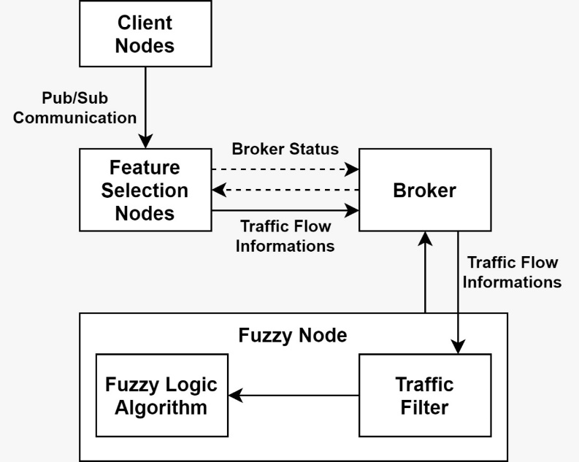
Figure 1. System design
  - Feature Selection (FS) Nodes
Nodes Feature Selection (FS) is responsible for observing the MQTT traffic flow on the network. Figure 2 shows a block diagram of the FS nodes. FS nodes will subscribe to the broker regarding traffic flow information using the broker status topic, namely $ SYS / broker / #, so that the broker will publish the required information in real-time. When the FS nodes get information from the broker, the FS nodes will publish the traffic flow information to the broker using a new topic, namely fuzzy / dtc / #, and the broker will save the topic. The required number of FS nodes is five nodes. This condition is due to the device's superficial characteristics so that each node cannot subscribe to more than one topic.

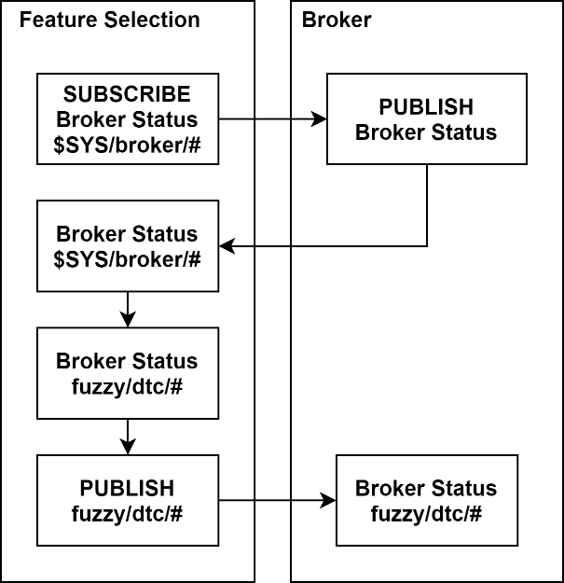
Figure 2. FS model nodes
  - Fuzzy Node
Fuzzy nodes are used to detect DoS attacks. Figure 3 shows a block diagram of fuzzy nodes. The fuzzy nodes will subscribe to the broker using the FS node's topics, namely fuzzy / dtc / # so that the fuzzy nodes can find out information about the MQTT traffic flow on the network. After the broker receives a subscribe from the fuzzy node, the broker will publish the fuzzy / dtc / # topic in real-time. Suppose the MQTT traffic flow information from the broker has been received. In that case, the fuzzy node will sort the SUBSCRIBE and SUBACK traffic using equations 1 and 2 to be used as input variables in the fuzzy logic algorithm. Fuzzy nodes will calculate the traffic ratio SUBSCRIBE and SUBACK to SMR and SAMR using equations 3 and 4.
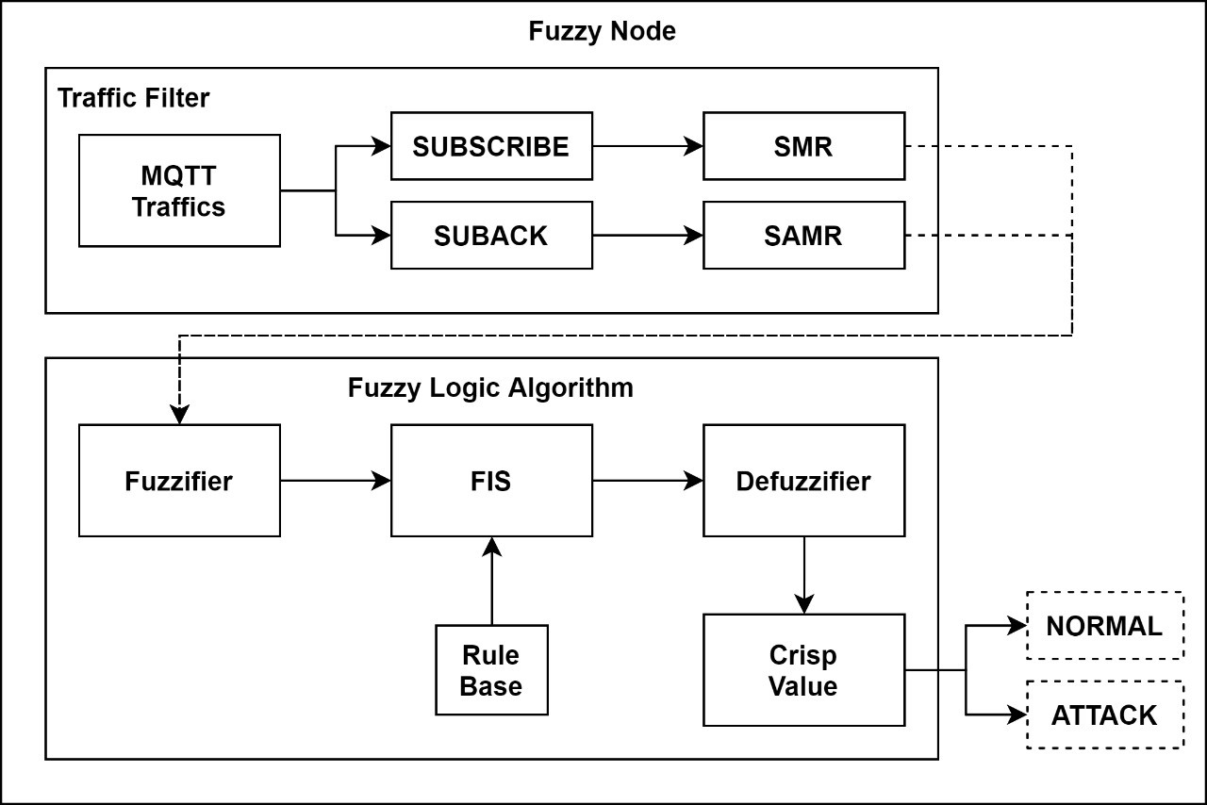
Figure 3. Fuzzy node model
The SMR and SAMR values ​​will be forwarded to the fuzzifier block, where this block will calculate the membership function (MF) of SMR and SAMR. Each variable will be grouped into linguistic variables based on their respective degrees of MF using the fuzzification process. There are three kinds of linguistic variables in SMR and SAMR, including "LOW," "MEDIUM," and "HIGH." The MF generated by the fuzzififier will be assigned to the FIS block. At this stage each MF will be adjusted to the rule bases that have been created using the logic "IF ... AND ... THEN ...". Table 1 shows the draft rule bases used. Adjusting MF to rule bases will result in conclusions in linguistic variables that indicate network conditions against DoS attacks. There are three kinds of conclusions produced, among others, "NORMAL," "ABNORMAL," and "SERANGAN." The conclusions obtained will be converted into crisp value by the defuzzifier block using the defuzzification process.
Table 1. Rule Bases
SMR | R | R | R | S | S | S | T | T | T
SAMR | R | S | T | R | S | T | R | S | T
Output | N | A | S | N | N | A | S | S | S

  - Experiment Setup
The fuzzy control or FIS method used is Mamdani, with the defuzzification method used is the centroid. The simulation was carried out using the COOJA network simulator with Mosquitto as the broker platform. The MQTT version used is MQTT v.3.1 with MQTT QoS level 0. The simulation is carried out using various scenarios, namely 15, 20, 25, and 30 nodes, with each scenario using an attack interval of 3, 5, 7, and 9 seconds. The number of attack nodes is 20% of the total number of nodes. The attacker will flood the network (flooding attack) using SUBSCRIBE traffic.

- Results and Analysis
  - Membership Function (MF) of Fuzzy Logic Algorithm
Table 2 shows the SMR value obtained using equation 3. Table 3 shows the SAMR value obtained using equation 4. Based on tables 2 and 3, the SMR and SAMR values ​​will increase along with the increase in the number of nodes or the increase in the attack's intensity. This attack is because the more the number of nodes, the traffic on the network will increase. The highest SMR value was obtained in the 25 nodes scenario during the ATK 3S attack interval with a value of 0.6308, while the lowest SMR value was obtained in the 20 nodes scenario when there was no attack with a value of 0.0541. The highest SAMR value was obtained during the ATK 3S attack interval at 15 nodes with a value of 0.3848, while the lowest SAMR value was obtained when there was no attack on 20 nodes with a value of 0.043.
Table 2. SMR value per scenario
Scenarios | 15 Nodes | 20 Nodes | 25 Nodes | 30 Nodes
ATK 3S | 0.5989 | 0.5582 | 0.6308 | 0.5982
ATK 5S | 0.4491 | 0.4961 | 0.5740 | 0.5636
ATK 7S | 0.4131 | 0.4293 | 0.4652 | 0.4707
ATK 9S | 0.3628 | 0.3413 | 0.4405 | 0.4078
No ATK | 0.0724 | 0.0541 | 0.1822 | 0.1092

Table 3. SAMR value per scenario
Scenario | 15 Nodes | 20 Nodes | 25 Nodes | 30 Nodes
ATK 3S | 0.3848 | 0.3455 | 0.3200 | 0.2410
ATK 5S | 0.2951 | 0.2217 | 0.2896 | 0.1421
ATK 7S | 0.2446 | 0.1351 | 0.2751 | 0.1988
ATK 9S | 0.2698 | 0.1620 | 0.1918 | 0.1233
No ATK | 0.0740 | 0.0430 | 0.0816 | 0.1654

Figures 4 and 5 show a graph of the mean SMR and SAMR values. This condition is done so that MF SMR and SAMR can detect DoS attacks. The highest average SMR value occurs in the 25 nodes scenario with a value of 0.5276, while the lowest average SMR value occurs in the 20 nodes scenario with a value of 0.0541. The highest average SAMR value occurs in the 15 nodes scenario with a value of 0.2986, while the lowest average SAMR value occurs in the 20 nodes scenario with a value of 0.043. Based on the obtained values ​​shown in Figures 4 and 5, the forms of MF SMR and SAMR used to detect DoS attacks are shown in Figures 6 and 7.

Figure 4. Average of SMR value

Figure 5. Average of SAMR value
Determination of the form of MF output is obtained based on the experimental results using the rule bases shown in table 1. There are three MF outputs to indicate network conditions, including "NORMAL," "ABNORMAL," and "SERANGAN." "R," "S," and "T" in the SMR and SAMR variables are "LOW," "MEDIUM," and "HIGH." "N," "A," and "S" in the output variable are "NORMAL," "ABNORMAL," and "SERANGAN." Crisp value is obtained using the defuzzification process. In this study, the defuzzification method used is the centroid method, which means that the crisp value will be obtained based on the resulting MF output's midpoint. To determine network conditions, when in a state, there is no attack or an attack is in progress, The centroid of MF "ABNORMAL" is used as the reference value where the midpoint of MF "ABNORMAL" is 0.375. Figure 8 is the MF of the output variable, which shows the network condition where if the crisp value is between zero and less than the reference value (0 ≤ crisps <0.375), it is assumed that there is no DoS attack on the network. If the crisp value is more significant than equal to the reference value until it is less than equal to one (0.375 ≤ crisps ≤ 1), it is assumed that a DoS attack is taking place on the network.

Figure 6. SMR membership function
Figure 7. SAMR membership function
Figure 8. Output membership function
  - False Positive Ratio (FPR)
False Positive Ration (FPR) is used to determine the fuzzy error rate when detecting an attack when there is no attack on the network. The equation for calculating the FPR parameter is listed in equation 5. Figure 9 shows the acquisition of the FPR value for each scenario. The lowest FPR is obtained in the 20 nodes scenario with a value of 0.1047; while the highest FPR is obtained in the 30 nodes scenario with a value of 0.4048.
$$\text{FPR = }\frac{{\text{N}}_{\text{FP}}}{\text{( }{\text{N}}_{\text{FP}}\text{ + }{\text{N}}_{\text{TN}}\text{ )}}$$ | (5)

Figure 9. FPR value per scenario
  - Accuracy
Accuracy used to determine the percentage of success in detecting an attack fuzzy when an attack occurs or does not occur. The equation for calculating accuracy is shown in equation 6. Figure 10 shows the accuracy percentage for each scenario. The highest accuracy was obtained in the 20 nodes scenario during the attack interval of ATK 5S with a percentage of 94.74%. In comparison, the lowest accuracy is obtained in the 30 nodes scenario during the ATK 9S attack interval with a percentage of 79.29%.
$$\text{Accuracy = }\frac{{\text{N}}_{\text{TP}} \text{+ }{\text{N}}_{\text{TN}}}{\text{(}{\text{ N}}_{\text{TP}}\text{ + }{\text{N}}_{\text{TN}}\text{ + }{\text{N}}_{\text{FP}}\text{ + }{\text{N}}_{\text{FN}}\text{ )}}\text{ × 100\%}$$ | (6)

Figure 10. Accuracy percentage per scenario
  - Precision
The precision is used to determine the number of attack detection results identified correctly among all attack detection results. The equation for calculating precision parameters is listed in equation 7. Figure 11 shows the acquisition of precision values ​​based on the test results for each scenario. The highest precision was obtained in the 20 nodes scenario at the attack interval of ATK 3S and ATK 9S with a value of 0.9082. The lowest precision is obtained in the 30 nodes scenario at the ATK 9S attack interval with a value of 0.7119.
$$\text{Precision = }\frac{{\text{N}}_{\text{TP}}}{\text{( }{\text{N}}_{\text{TP}}\text{ + }{\text{N}}_{\text{FP}}\text{ )}}$$ | (7)

Figure 11. Precision value per scenario
  - Recall
The recall is used to determine the number of attack detection results that are correctly identified at the attack time. The equation for calculating the recall parameter is shown in equation 8. Figure 12 shows the recall value obtained from the test results for each scenario. The recall value in each scenario has relatively the same value. Suppose the recall value of each scenario is averaged. In that case, the best average recall value is obtained in the 15 nodes scenario with an average value of 1. In comparison, the lowest average recall value is obtained in the 20 nodes scenario with an average value of 0.9914.
$$\text{Recall = }\frac{{\text{N}}_{\text{TP}}}{\text{( }{\text{N}}_{\text{TP}}\text{ + }{\text{N}}_{\text{FN}}\text{ )}}$$ | (8)

Figure 12. Average recall per scenario
  - F-Score
F-score used to average the precision with recall. The equation for calculating the f-score parameter is listed in equation 9. Figure 13 shows the f-score value obtained from each test scenario. The highest F-score was obtained in the 20 nodes scenario during the attack interval of ATK 5S with a value of 0.9497; while the lowest f-score is obtained in the 30 nodes scenario at the ATK 9S attack interval with a value of 0.8276.
$$\text{F-Score = }\frac{\text{2 × Precision × Recall}}{\text{Precision + Recall}}$$ | (9)

Figure 13. F-Score value per scenario
  - Fuzzy Logic Algorithm Analysis
Table 4 shows the average value of the performance of the fuzzy logic algorithm in each scenario. When there is no attack, the fuzzy logic algorithm's best performance is obtained in the 20 nodes scenario. It can be seen in table 4 that the 20 nodes scenario has the lowest FPR. Meanwhile, when there is an attack, the fuzzy logic algorithm's best performance is obtained in the 15 nodes scenario. It can be seen in table 4 that the 15 node scenario has the highest recall. This is due to the limitation of the fuzzy nodes that can only accept a maximum of two topics simultaneously. There was very little traffic intensity in the 15 nodes scenario when there was no attack. This causes the fuzzy nodes to receive more than two topics at the same time (exceeding the receiving capacity) so the fuzzy nodes will discard that information from the broker. Meanwhile, the traffic intensity in the 15 nodes scenario when an attack occurs follows the fuzzy nodes' receiving capacity so that the fuzzy nodes can well receive the topics sent by the broker. In contrast to the 20 nodes scenario when there is no attack, the traffic intensity follows the fuzzy nodes' receiving capacity so that all information sent by the broker can be well received. However, when an attack occurs in the 20 nodes scenario, the traffic intensity is high enough, causing delays in exchanging information between brokers and fuzzy nodes. This creates an error on the fuzzy nodes when filtering traffic and detecting DoS attacks. Therefore, the highest FPR is obtained in the 20 nodes scenario, and the highest recall is obtained in the 15 nodes scenario.

Table 4. The average performance of fuzzy logic per scenario
Scenarios | FPR | Accuracy | Precision | Recall | F-Score
15 Nodes | 0.1591 | 92.00% | 0.8613 | 1,0000 | 0.9255
20 Nodes | 0.1047 | 94.39% | 0.9062 | 0.9915 | 0.9469
25 Nodes | 0.3256 | 83.72% | 0.7570 | 0.9972 | 0.8607
30 Nodes | 0.4048 | 79.88% | 0.7166 | 0.9971 | 0.8339

Determination of the highest network condition that was correctly identified during the attack or when the attack did not occur was obtained in the 20 nodes scenario. In comparison, the determination of the lowest network condition was obtained in the 30 nodes scenario. It can be seen from the obtained accuracy shown in table 4. The highest detection results for attacks that were correctly identified when an attack occurred or when an attack did not occur were obtained in the 20 nodes scenario. In comparison, the lowest level of attack detection results was obtained in the 30 nodes scenario. It can be seen from the acquisition of precision shown in Table 4. Overall, the fuzzy logic algorithm's best average performance when an attack occurs or does not occur is obtained in the 20 nodes scenario. In comparison, the worst fuzzy logic algorithm's average performance is obtained in the 30 nodes scenario. It can be seen from the f-score acquisition shown in table 2. This is because in the 20 nodes scenario, the fuzzy logic algorithm's performance when an attack does not occur. It can be seen from the low FPR in the 20 nodes scenario so that the accuracy, precision, and f-score parameters will be the highest. Meanwhile, in the 30 nodes scenario, the fuzzy logic algorithm's performance is terrible when there is no attack. It can be seen from the high FPR in the 30 nodes scenario so that the accuracy, precision, and f-score parameters will be the lowest. Meanwhile, in the 30 nodes scenario, the fuzzy logic algorithm's performance when there is no attack is very bad. It can be seen from the high FPR in the 30 nodes scenario so that the accuracy, precision, and f-score parameters will be the lowest. Meanwhile, in the 30 nodes scenario, the fuzzy logic algorithm's performance when there is no attack is very bad. It can be seen from the high FPR in the 30 nodes scenario so that the accuracy, precision, and f-score parameters will be the lowest.

- Conclusions
The ability of fuzzy nodes to receive topics simultaneously amounts to a maximum of two topics. This can cause errors in the fuzzy logic algorithm when detecting DoS attacks. FPR is inversely proportional to accuracy, precision, and f-score. The highest FPR is obtained in the 30 nodes scenario with a value of 0.4048; while the lowest FPR is obtained in the 20 nodes scenario with a value of 0.1047. Accuracy, precision, and f-score in the 30 nodes scenario had the lowest values, namely 79.88%, 0.7166, and 0.8339. Accuracy, precision, and f-score in the 20 nodes scenario had the highest values, namely 94.39%, 0.9062, and 0.9469. The highest average recall is obtained in the 15 nodes scenario with a value of 1, which means that all detection results of the fuzzy logic algorithm when an attack occurs in the 15 nodes scenario have a perfect detection rate. Future developments can use other fuzzy controller methods such as the Takagi-Sugeno method or the Tsukamoto method.

- References

[1] AP Haripriya, “Secure-MQTT: an efficient fuzzy logic-based approach to detect DoS attack in MQTT protocol for internet of things,2019.
[2] A. Velinov and A. Mileva, "Running and Testing Applications for Contiki OS Using Cooja Simulator," no. June 2016, 2018.
[3] M. Yassine, A. Ezzati, and M. Belaissaoui, "An Enhanced DTLS Protocol for Internet of Things Applications," no. February 2018, 2016.
[4] P. Kasinathan, C. Pastrone, MA Spirito, and M. Vinkovits, "Denial-of-Service detection in 6LoWPAN based Internet of Things," no. October, 2013.
[5] W. Li, S. Tug, W. Meng, and Y. Wang, "Designing collaborative blockchained signature-based intrusion detection in IoT environments," Futur. Gener. Comput. Syst., vol. 96, pp. 481–489, 2019.
[6] MS Harsha, BM Bhavani, and KR Kundhavai, "Analysis of vulnerabilities in MQTT security using Shodan API and implementation of its countermeasures via authentication and ACLs," 2018 Int. Conf. Adv. Comput. Commun. Informatics, pp. 2244–2250, 2018.
[7] S. Andy, B. Rahardjo, and B. Hanindhito, "Attack Scenarios and Security Analysis of MQTT Communication Protocol in IoT System," no. May, 2018.
[8] S. Shin, K. Kobara, CC Chuang, and W. Huang, "A security framework for MQTT," 2016 IEEE Conf. Commun. Netw. Secur. CNS 2016, pp. 432–436, 2017.
[9] G. Potrino and AF Santamaria, "Modeling and evaluation of a new IoT security system for mitigating DoS attacks to the MQTT broker," 2019 IEEE Wirel. Commun. Netw. Conf., pp. 1–6, 2019.
[10] S. Hameed, FI Khan, and B. Hameed, "Understanding Security Requirements and Challenges in the Internet of Things (IoT): A Review," Journal of Computer Networks and Communications, vol. 2019.2019.
[11] G. Potrino, F. De Rango, and P. Fazio, "A Distributed Mitigation Strategy against DoS attacks in Edge Computing," Wirel. Telecommun. Symp., vol. 2019-April, pp. 1–7, 2019.
[12] SK Yee and J. V Milanovi, “Fuzzy Logic Controller for Decentralized Stabilization of Multimachine Power Systems,” vol. 16, no. 4, pp. 971–981, 2008.
[13] M. Alali, A. Almogren, MM Hassan, IAL Rassan, and Z. Alam, "Improving Risk Assessment Model of Cyber ​​Security Using Fuzzy Logic Inference System," Comput. Secur., 2017.
[14] S. Dick, “Toward Complex Fuzzy Logic,” vol. 13, no. 3, pp. 405–414, 2005.
[15] A. Machado et al., "A Fuzzy Inference System to Support Medical Diagnosis in Real Time," Procedia Comput. Sci., Vol. 122, pp. 167–173, 2017.
[16] K. Ozera, K. Bylykbashi, Y. Liu, and L. Barolli, "A Fuzzy-Based Approach for Cluster Management in VANETs: Performance Evaluation for Two Fuzzy-Based Systems," Internet of Things, 2018.
[17] AF Santamaria and F. De Rango, "A real IoT device deployment for E-Health applications under lightweight communication protocols, activity classifier and Edge data filtering," Comput. Commun., 2018.
[18] MS Munir, IS Bajwa, and SM Cheema, “An intelligent and secure smart watering system using fuzzy logic and blockchain ✩, ”Comput. Electr. Eng., Vol. 77, pp. 109–119, 2019.
[19] N. Upasani and H. Om, "A modified neuro-fuzzy classifier and its parallel implementation on modern GPUs for real time intrusion detection," Appl. Soft Comput. J., vol. 82, p. 105595, 2019.
[20] Rahmat, Firman A., et al. "Prototype of Ship Robot for Measuring PH Level and Water Turbidity Based on Modified Fuzzy Method." Journal of Electrical Engineering, vol. 14, no. 1, 2018, pp. 43-50, doi: 10.17529 / jre.v14i1.9771.
[21] SH Ramos, MT Villalba, and R. Lacuesta, “MQTT Security: A Novel Fuzzing Approach,” vol. 2018, 2018.

